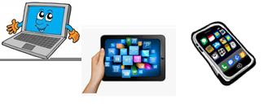
Name:…
Surname: …
Home Schooling 15
I CAN DO IT!

- Look at page 20 from the Pupil’s book.

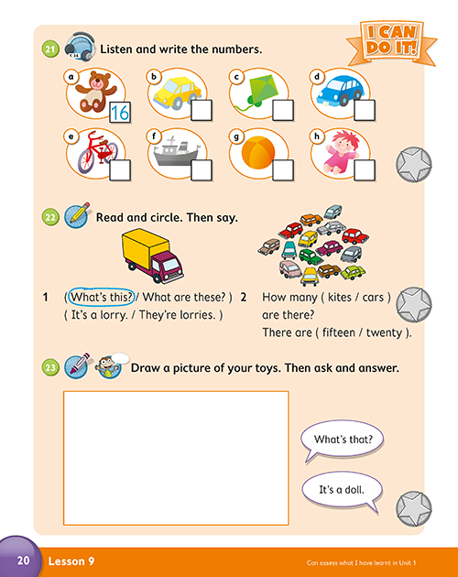

- Look and choose A or B. Then answer.

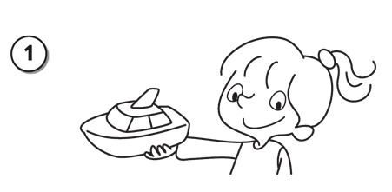
A What’s this? / B What are those?
A What’s this?
It’s a boat.

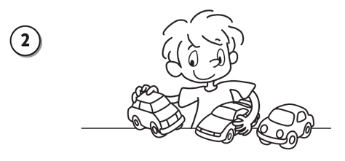
A What’s this? / B What are these?
…
They’re ...

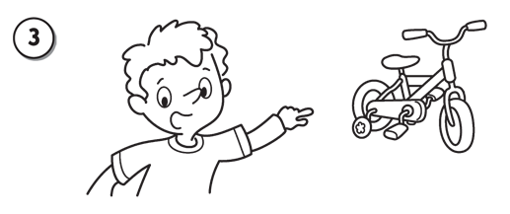
A What’s that? / B What are these?
…
...

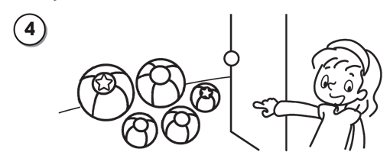
A What’s that? / B What are those?
…
...

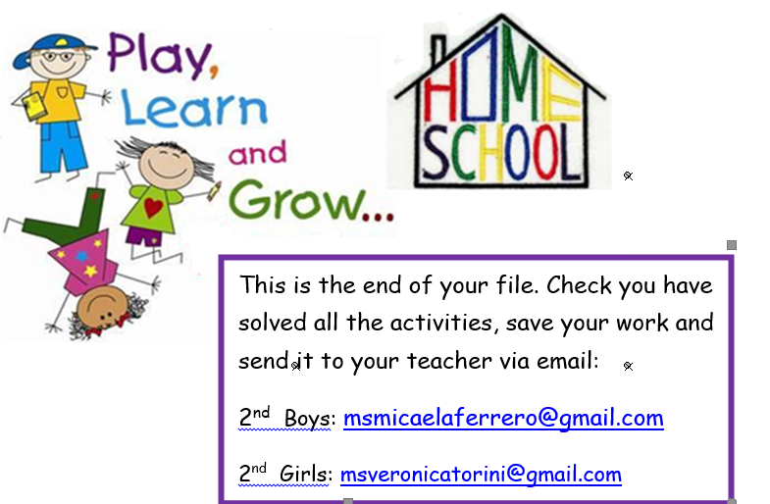

NOW CLICK AND WORK ONLINE:
https://forms.gle/bqmdvHgKF8yRFfAL8
PLEASE PRESS “SUBMIT/SEND” AT THE END OF YOUR ONLINE WORK
POR FAVOR PRESIONAR “ENVIAR” AL FINAL DEL TRABAJO EN LINEA

