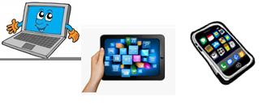
Name:…
Surname: …
Home Schooling 20
*GO TO YOUR PUPIL´S BOOK, PAGE 23.
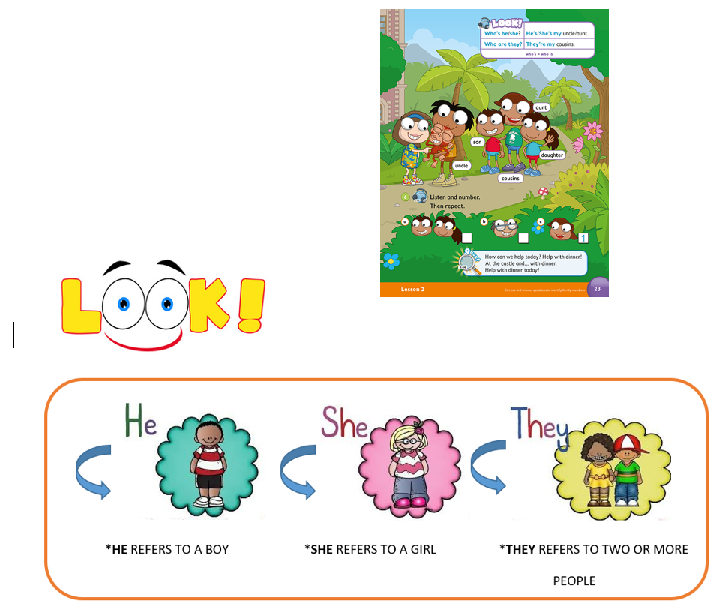
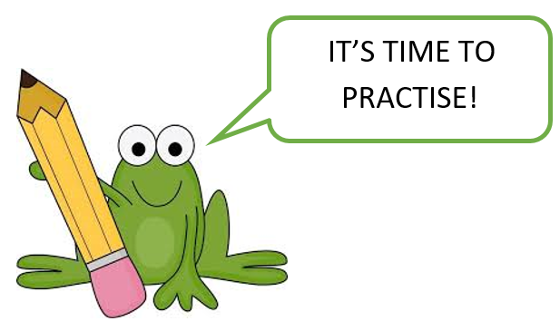
CLICK AND WORK ONLINE.
https://forms.gle/E8jjHENQ2uF2tpU5A

PLEASE PRESS “SUBMIT/SEND” AT THE END OF YOUR ONLINE WORK.
POR FAVOR PRESIONAR “ENVIAR” AL FINAL DEL TRABAJO EN LINEA.

Press ctrl and click to listen to the audio file:
*LISTEN AND WRITE. https://bit.ly/2Lcr511
…
…
…

