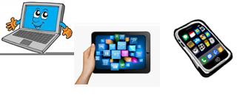
Name:…
Surname: …
Home Schooling 22
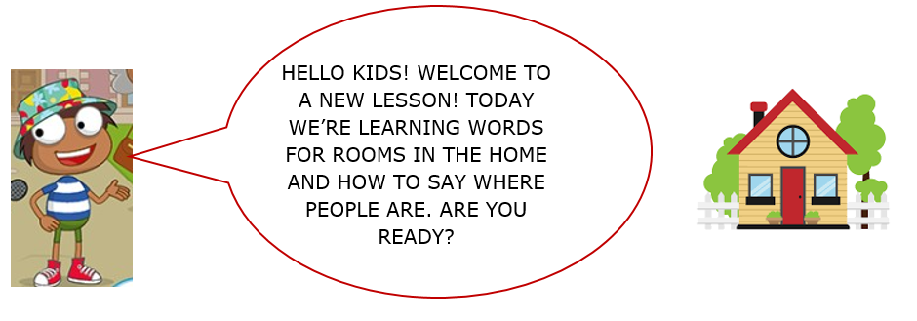

1) OPEN YOUR PUPIL’S BOOK, PAGE 24, EXERCISE 7.
Press ctrl and click to listen to the audio file:
https://bit.ly/3dOrF1b
-FIND THE STICKERS FOR UNIT 2 AT THE END OF YOUR BOOK.
-LISTEN AND STICK. THEN LISTEN AGAIN AND SAY.

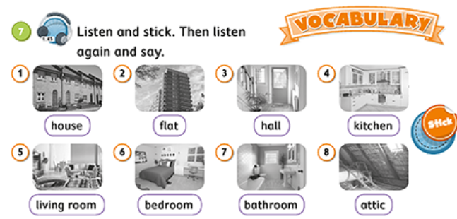

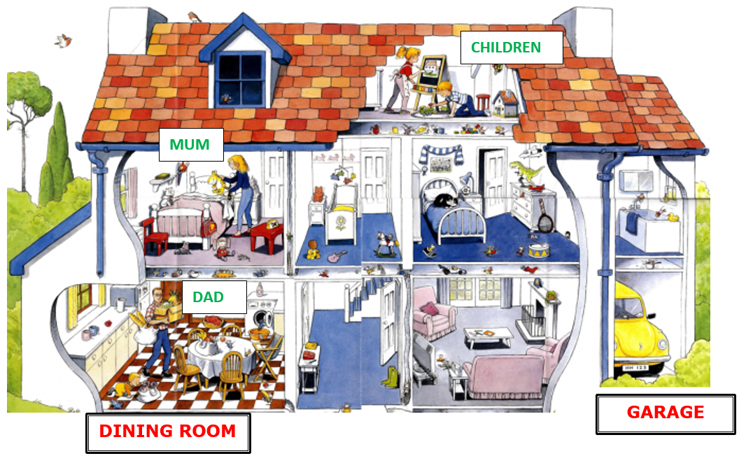
2) LABEL THE PARTS OF THIS HOUSE.
THIS IS A …
B…S
…
…

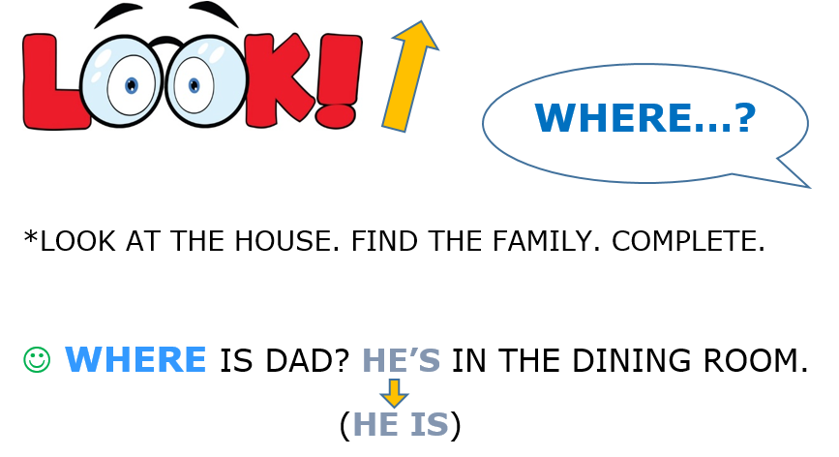
WHERE IS MUM? SHE’S IN THE B … M.
(SHE IS)

WHERE ARE THE CHILDREN? THEY’RE IN THE ...
(THEY ARE)

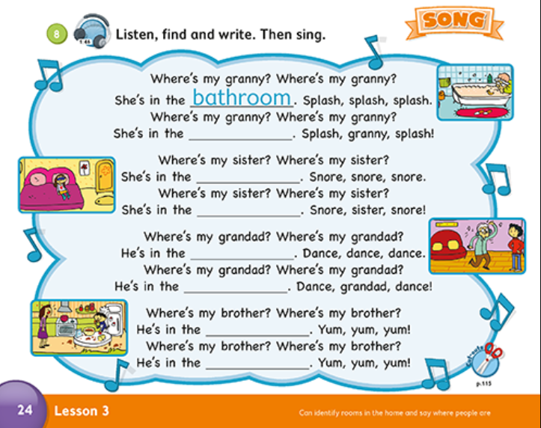
3) PAGE 24, EXERCISE 8.
TO DO THIS EXERCISE, LET’S
GO ONLINE!
NOW GO ONLINE

CLICK AND WORK ONLINE:
https://forms.gle/jq2F5A6M75pHsaPF9
PLEASE PRESS “SUBMIT/SEND” AT THE END OF YOUR ONLINE WORK.
POR FAVOR PRESIONAR “ENVIAR” AL FINAL DEL TRABAJO EN LINEA.

