Name:…
Surname: …
Home Schooling 23 A-B
PART A
PRESS CTRL+CLICK TO PLAY
https://bit.ly/3fRmcsj
1- PLAY THIS HANGMAN!
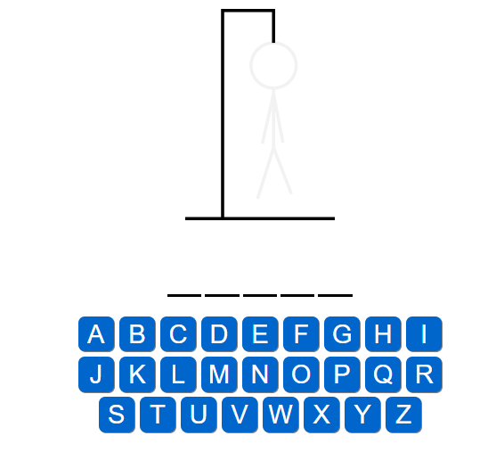

PRESS CTRL+CLICK TO PLAY
https://bit.ly/2Lsv35T

2- PLAY THIS MEMOTEST TO REVISE THE PARTS OF THE HOUSE!

NOW GO ONLINE

CLICK AND WORK ONLINE.
HS 23 A: https://forms.gle/8dGJDNJy1NQSuw3QA
HS 23 B: https://forms.gle/sp5rd6r6WRAENk5X9
PLEASE PRESS “SUBMIT/SEND” AT THE END OF YOUR ONLINE WORK.
POR FAVOR PRESIONAR “ENVIAR” AL FINAL DEL TRABAJO EN LINEA.

AFTER WORKING ONLINE, COME BACK TO THIS FILE TO SOLVE PART B

PART B

WRITE ABOUT YOUR FAMILY
EXAMPLE: HOW MANY AUNTS HAVE YOU GOT?
I’VE GOT ONE AUNT.

A- HOW MANY AUNTS HAVE YOU GOT?
…

B- HOW MANY UNCLES HAVE YOU GOT?
…

C- HOW MANY COUSINS HAVE YOU GOT?
…

