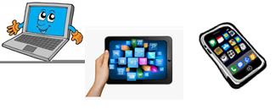

***Name:…***

***Surname: …***

***Home Schooling 16***

**WE CAN DO IT!**



1. **LOOK AT MS MICA AND MS VERO!**

**WATCH THE VIDEO AND PAY ATTENTION!**

|  |
| --- |
| Press ctrl and click to watch the video: |
| <https://bit.ly/2Vy5BBD> |
|  |
|  |



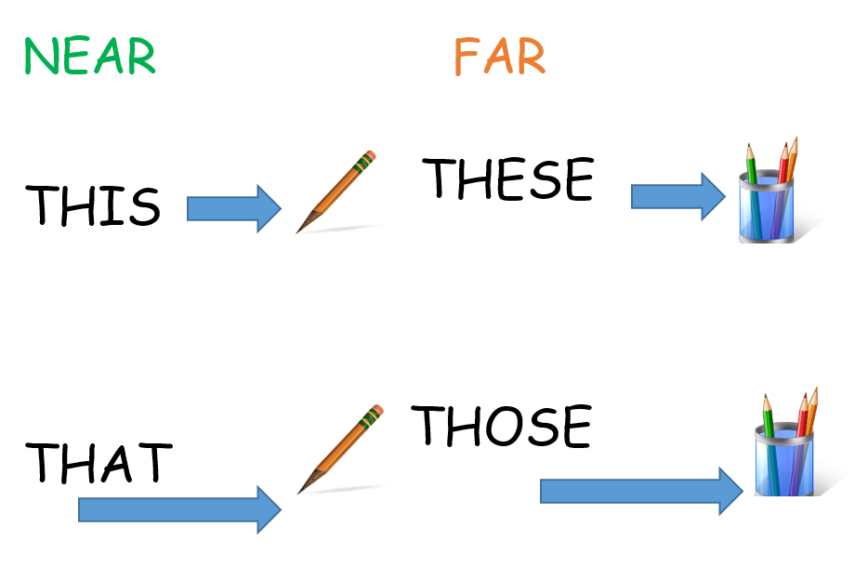

1. **COMPLETE THE** … **WITH *THIS*, *THAT*, *THESE* OR *THOSE***

|  |  |
| --- | --- |
| … IS A COMPUTER GAME |  |
| … ARE LORRIES. | C:\Users\Kate\AppData\Local\Microsoft\Windows\Temporary Internet Files\Content.IE5\B76H5MVK\MC900236987[1].wmfC:\Users\Kate\AppData\Local\Microsoft\Windows\Temporary Internet Files\Content.IE5\B76H5MVK\MC900236987[1].wmf |
| … IS A CAMERA. | C:\Users\Kate\AppData\Local\Microsoft\Windows\Temporary Internet Files\Content.IE5\OEH470XG\MC900433873[1].png |
| … ARE BALLS. |  |
| … IS A KITE. |  |

1. **READ AND DECIDE IF THEY ARE NEAR O FAR**

**THIS** CAT NEAR

**THOSE** PRESENTS …

**THAT** CHOCOLATE CAKE …

**THOSE** TOMATOES …

**THESE** PARTY HATS …

**THESE** POTATO CHIPS …

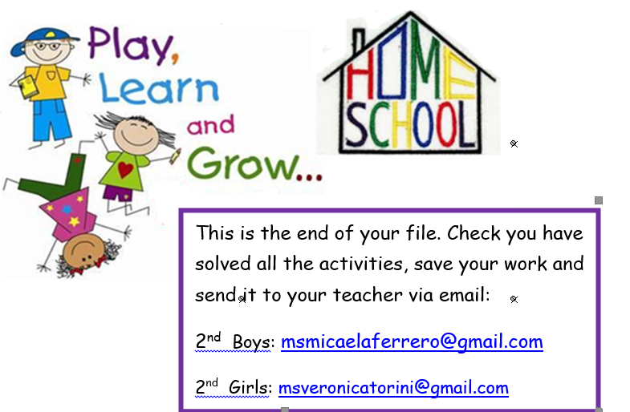

**NOW GO ONLINE**

**WORK ONLINE**

[**https://forms.gle/FYU9hcJ5YEYzriUR6**](https://forms.gle/FYU9hcJ5YEYzriUR6)

|  |
| --- |
| **PLEASE PRESS “SUBMIT/SEND” AT THE END OF YOUR ONLINE WORK**  **POR FAVOR PRESIONAR “ENVIAR” AL FINAL DEL TRABAJO EN LINEA** |

