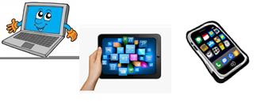
Name:…
Surname: …
Home Schooling 17
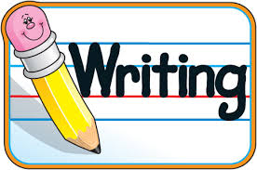
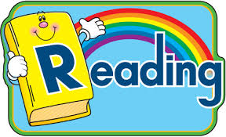
And

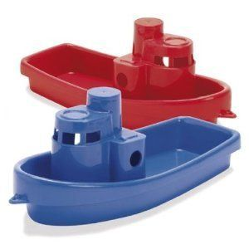
- READ THIS LETTER.
Dear Aunt Emma,
Thank you for my boat. I love boats! I’ve got two boats – a blue boat from you and a red boat from my friend Tina!
I’ve got a green bike from Mum and Dad and six blue dolls from Granny and Grandad. And I’ve got a teddy bear from my sister Rachel.
Thank you!
Love from
Anne x

*READ AGAIN. THEN WRITE YES OR NO.

- There are two boats. YES
- Aunt Emma’s boat is red. …
- The bike is green. …
- There are five dolls. …
- There is a teddy bear. …
- Rachel is Anne’s friend. …

- NOW, DO THIS CROSSWORD! (PRESS CNTRL AND CLICK ON THE WORD “CROSSWORD” OR HERE: https://es.educaplay.com/recursos-educativos/5511832-toys.html)
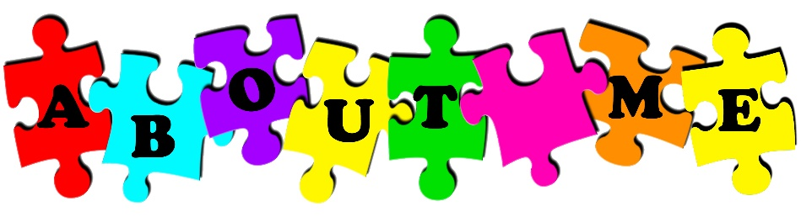

- LOOK AT THE PICTURE, READ AND COMPLETE.
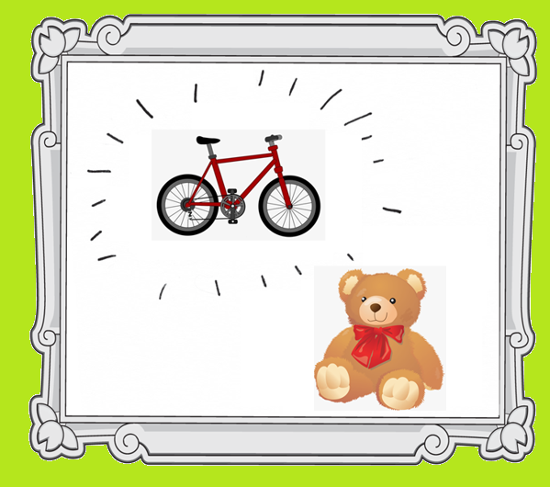
BIKE FAVOURITE SCHOOL TEDDY

THESE ARE MY 1- FAVOURITE TOYS.
THIS IS MY FAVOURITE 2- … BEAR.
HIS NAME’S FRED AND HE’S BROWN.
AND THIS IS MY 3- …
IT’S RED AND BLACK.
I GO TO 4- … BY BIKE.

- FIND TWO OF YOUR FAVOURITE TOYS AND WRITE
THESE ARE MY FAVOURITE TOYS.
THIS IS MY FAVOURITE …
IT’S … (COLOUR)
AND THIS IS MY FAVOURITE …
IT’S … (COLOUR)

PREPARE SHOW US THESE TOYS AT OUR NEXT ZOOM SESSION!!!

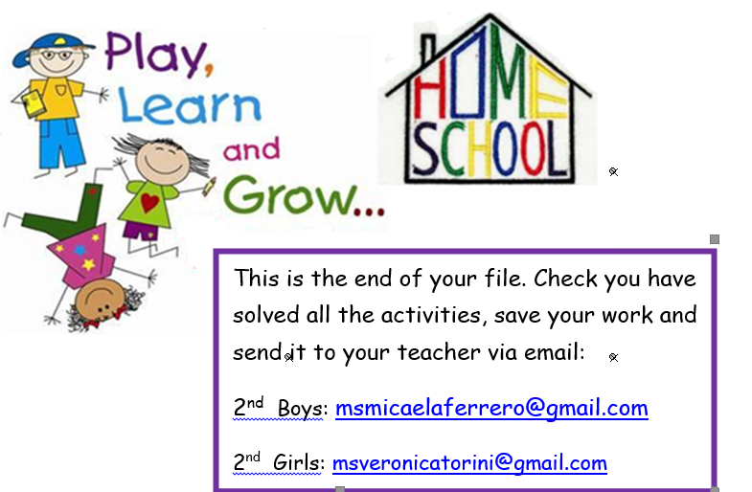

NOW GO ONLINE

CLICK AND WORK ONLINE:
https://forms.gle/fSuR9DZuJvATMksJ8
PLEASE PRESS “SUBMIT/SEND” AT THE END OF YOUR ONLINE WORK
POR FAVOR PRESIONAR “ENVIAR” AL FINAL DEL TRABAJO EN LINEA

