Name:…
Surname: …
Home Schooling 18
MEET THE CHARACTERS OF OUR STORY

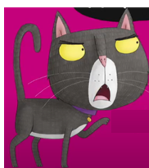 | C A T | F R O G | 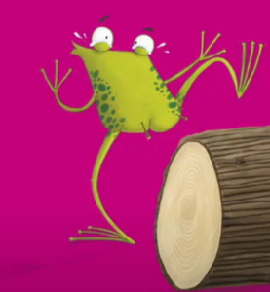

THIS STORY HAS MANY ANIMALS!

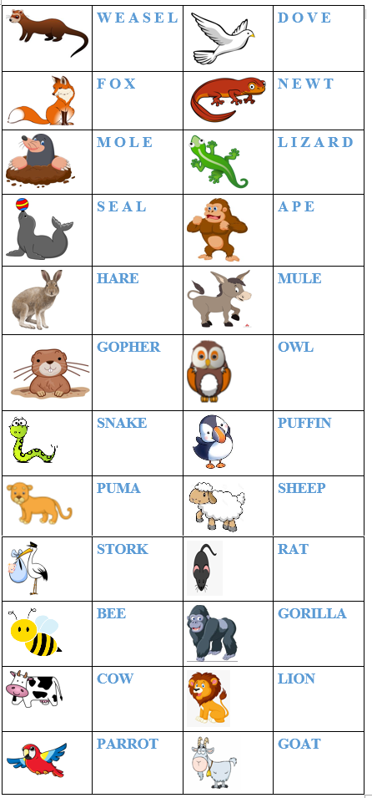

A –MATCH THE ANIMALS WITH THEIR NAMES AT:
https://forms.gle/6fJTBBd2Rc39kQJe6

B- SOLVE A WORDSEARCH AT :
https://es.educaplay.com/recursos-educativos/5606450-animals_ii.html

C – COMPLETE THE CHART. USE THE NAMES FROM THE WORDSEARCH
HINT: PARROT / RAT / STORK / COW / GORILLA / GOAT

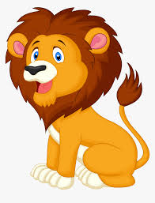 | 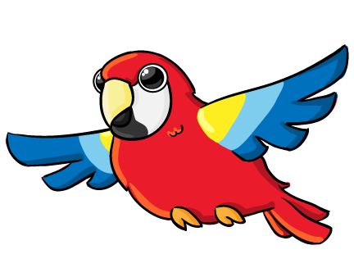 | 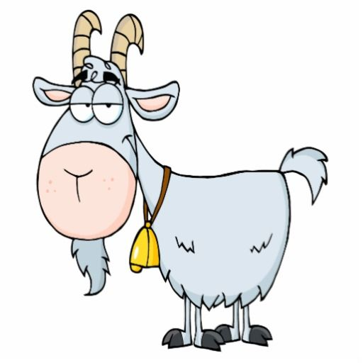 |  | 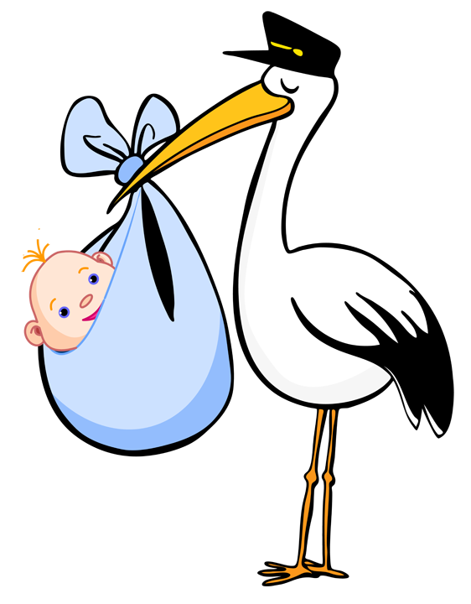 |  | 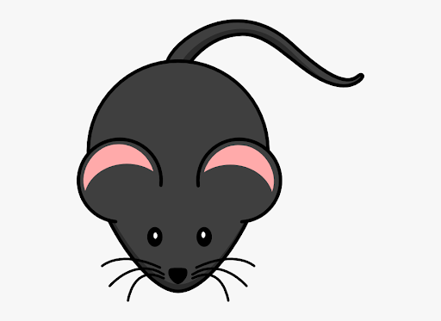
LION | ... | ... | ... | ... | ... | ...

D – CLICK HERE https://wordwall.net/es/resource/1857811/oi-frog-animals
TO PLAY THIS QUIZ AND SEE HOW MANY ANIMALS YOU REMEMBER!
PLEASE WRITE DOWN YOUR SCORE!
…

E –
READ, WATCH THE STORY AND ENJOY!
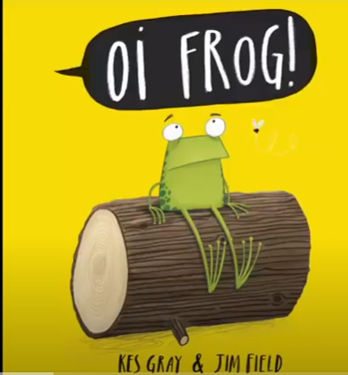
Press ctrl and click
to watch the video:

https://youtu.be/h5mjvvDZJQE

F- MATCH

WHERE DO THE ANIMALS SIT ON?
READ THE STORY AGAIN AND MATCH THE ANIMALS WITH THE PLACE THEY SIT ON

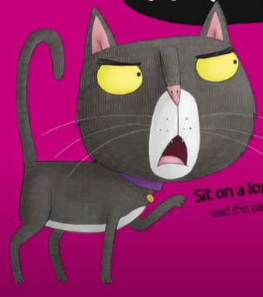  A | 1 LOG
B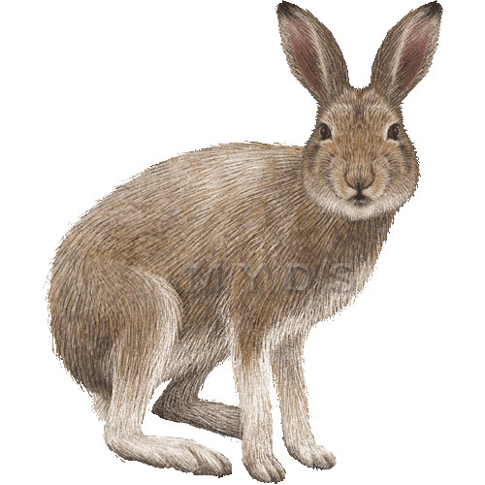 | 2 CHAIR
C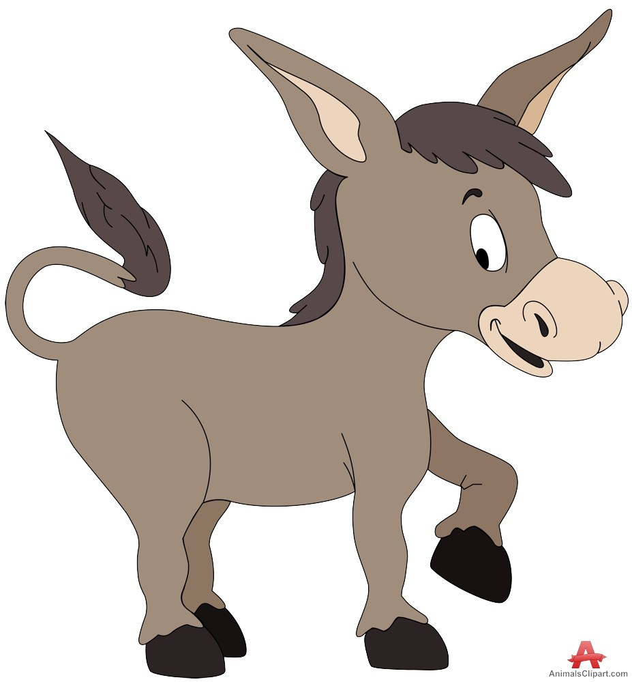 | 3 MAT
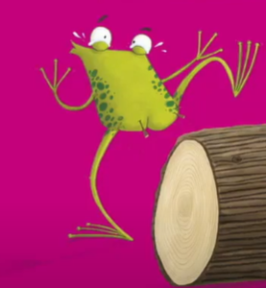  D | 4 SOFA
E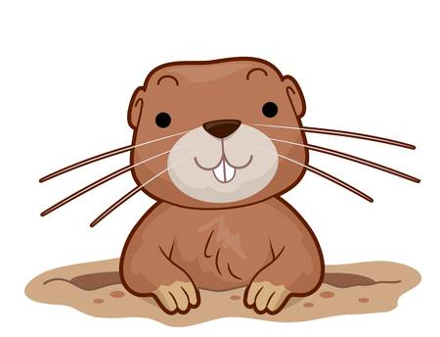 | 5 GRAPES
F | 6 HATS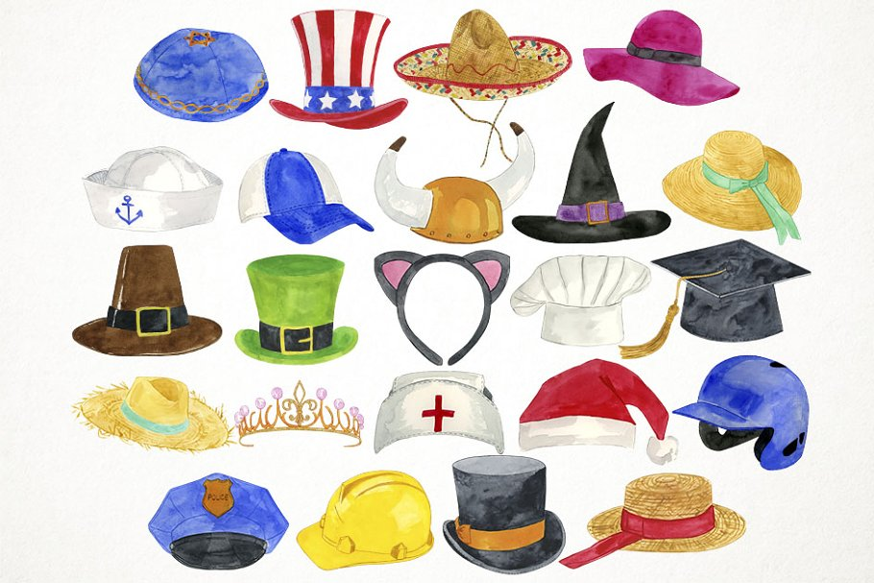
G | 7 WIZARD
H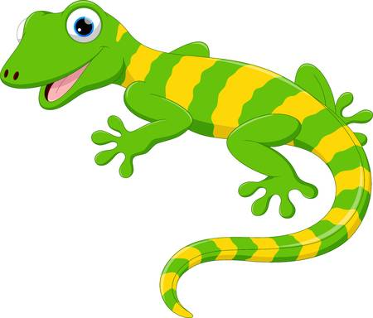 | 8 STOOL
I | 9 MUFFIN

- 3 | - ... | C -... | D -... | E -...
F- ... | G- ... | H- ... | I-...

G- COMPLETE

GLOVES WHEELS TOWELS

CAKES KEYS

1- SEALS SIT ON…
2- DOVES SIT ON…
3- SNAKES SIT ON…
4- OWLS SIT ON…
5- BEES SIT ON…
WATCH THESE VIDEOS AND PAY ATTENTION!
Press ctrl and click  to watch the video https://youtu.be/h94Vp8TwkYE |  | Press ctrl and click  to watch the video: https://youtu.be/RRIeiVHD5OU

H- FIND FOUR PAIRS OF WORDS THAT RHYME
EXAMPLE: Cat - mat
Frog - Log
1- …
2-…
3-…
4-…

I- IT’S YOUR TURN!
THINK ABOUT AN ANIMAL AND SOMETHING FOR
THE ANIMAL TO SIT ON. BE CAREFUL! THEY HAVE TO RHYME!
EXAMPLE . DUCKS SIT ON TRUCKS.
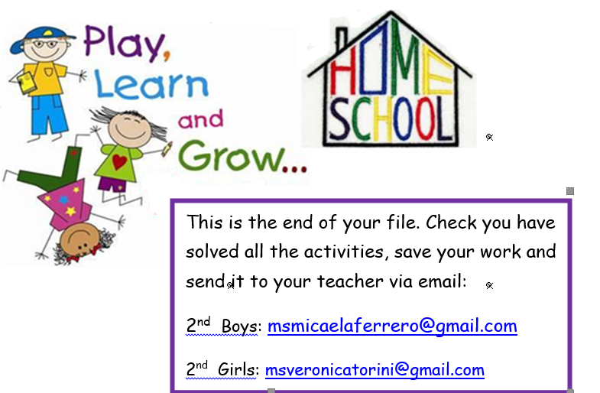
1- …

