Name:…
Surname: …
Home Schooling 19
HELLO KIDS!
WELCOME TO UNIT 2!

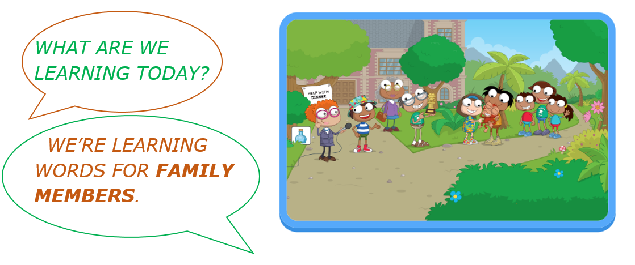
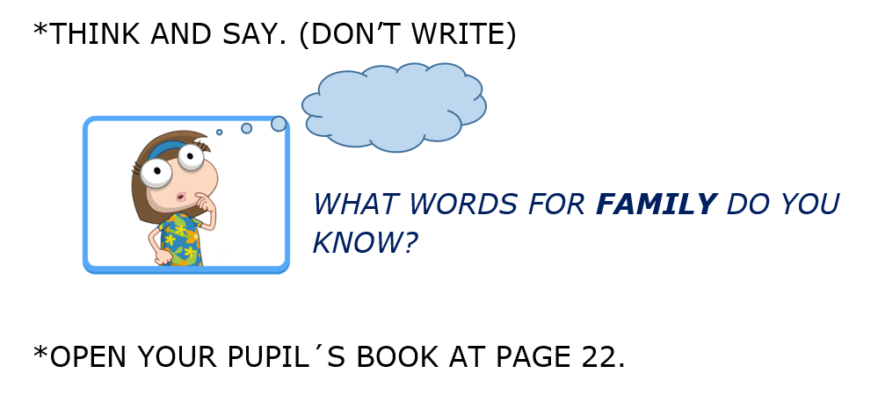
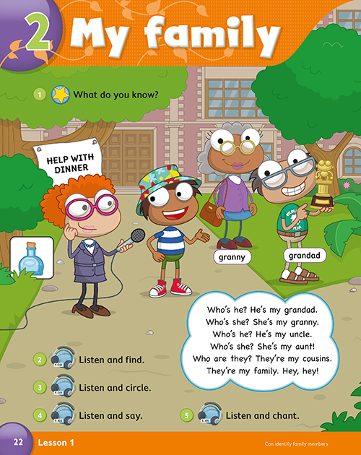
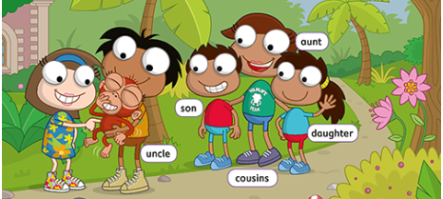
Press ctrl and click to listen to the audio file:
https://bit.ly/2WekpVb
- LISTEN TO CHARLIE AND POINT TO HIS FAMILY.

b) LISTEN AND SAY. THEN WRITE THE FAMILY WORDS.
Press ctrl and click to listen to the audio file:
https://bit.ly/3aTGiyq

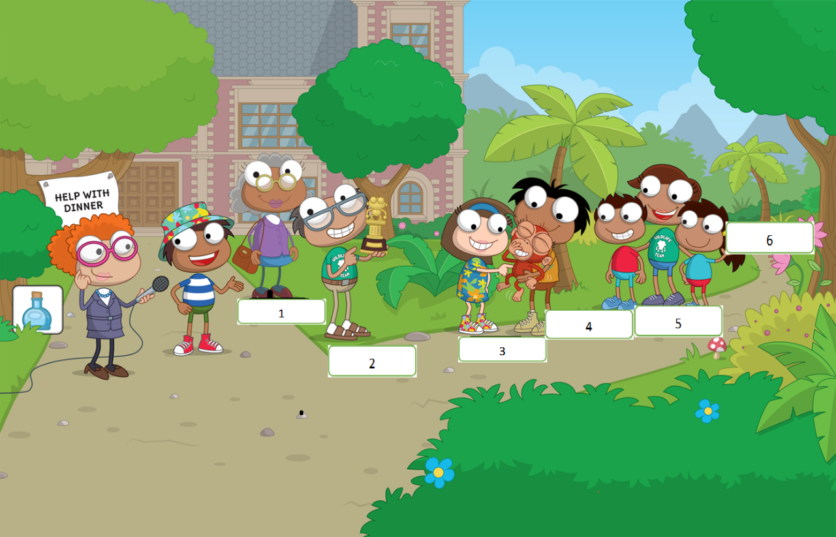

1 GRANNY

2 …
3 …
4 …
5 …
6 …
LET’S PRACTISE!
…

- LOOK AND WRITE
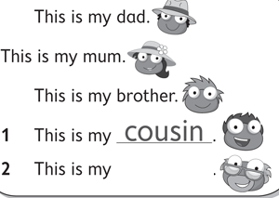
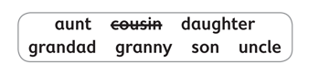
CHARLIE

…

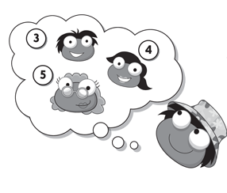 | 3-This is my …  4 This is my …  5 This is my …
6-This is my …  7 This is my … | 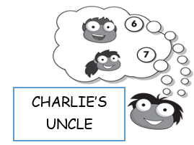

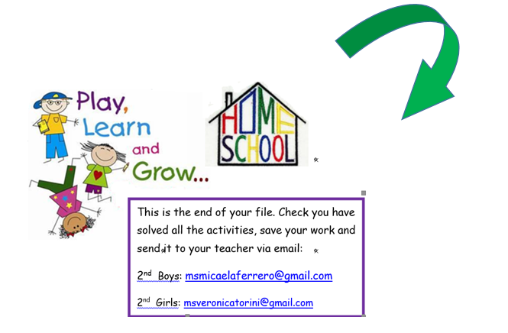
NOW GO ONLINE

NOW CLICK AND WORK ONLINE:
https://forms.gle/TWZ53EpKyj9ayVp78

PLEASE PRESS “SUBMIT/SEND” AT THE END OF YOUR ONLINE WORK.
POR FAVOR PRESIONAR “ENVIAR” AL FINAL DEL TRABAJO EN LINEA.

