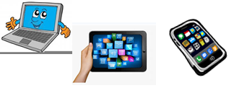
Name:…
Surname: …
Home Schooling 21
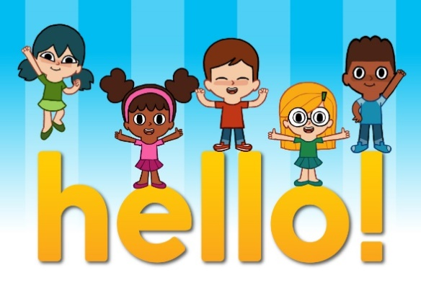
GO ONLINE

CLICK AND WORK ONLINE.
https://forms.gle/sn3GTw5yioRpyiWt6
PLEASE PRESS “SUBMIT/SEND” AT THE END OF YOUR ONLINE WORK.
POR FAVOR PRESIONAR “ENVIAR” AL FINAL DEL TRABAJO EN LINEA.

PASTE A PICTURE OF YOUR FAMILY AND TELL US ABOUT IT!

THIS IS MY FAMILY!
INSERT PICTURE HERE
EXAMPLE: THIS IS MY MUM, ALICIA.
THIS IS MY DAD, JUAN.
THIS IS MY BROTHER, PEDRO.
THIS IS MY COUSIN, …
THIS IS MY AUNT, …
ETC.

THIS IS MY … , …
THIS IS MY … , …
THIS IS MY … , …
THIS IS MY … , …
THIS IS MY … , …
THIS IS MY … , …
