

***Name:…***

***Surname: …***

***Home Schooling 24***



**TODAY WE´LL LEARN TO ASK AND ANSWER QUESTIONS ABOUT WHERE PEOPLE AND THINGS ARE.**

**PART A**



DO YOU REMEMBER?

(FROM POPTROPICA 1)

(

NOW GO ONLINE

**CLICK AND WORK ONLINE.**

**HS 24 A:** [**https://forms.gle/dAqhCMvYxRdo6Fxf9**](https://forms.gle/dAqhCMvYxRdo6Fxf9)

|  |
| --- |
| **PLEASE PRESS “SUBMIT/SEND” AT THE END OF YOUR ONLINE WORK.**  **POR FAVOR PRESIONAR “ENVIAR” AL FINAL DEL TRABAJO EN LINEA.** |

**AFTER WORKING ONLINE, COME BACK TO THIS FILE TO SOLVE PART B**



**PART B**

**NOW, WATCH THIS VIDEO YOUR TEACHERS MADE FOR YOU!**

**CLICK:** <https://bit.ly/3bXKXjn>

1. 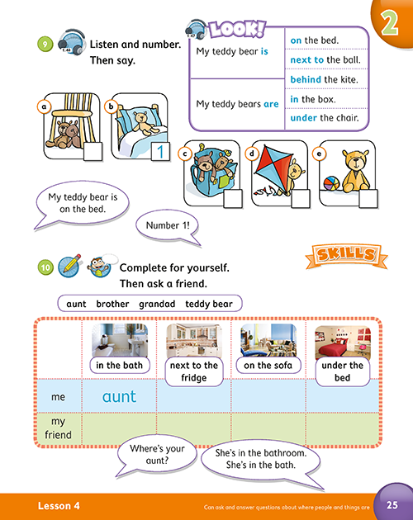**OPEN YOUR PUPIL’S BOOK, PAGE 25.**

**PAY ATTENTION TO THE *LOOK!* BOX.**

**LISTEN AND POINT TO THE PICTURES.**

|  |
| --- |
| smiley small Press ctrl and click to listen to the audio file: |
| <https://bit.ly/2A1JNpT> |

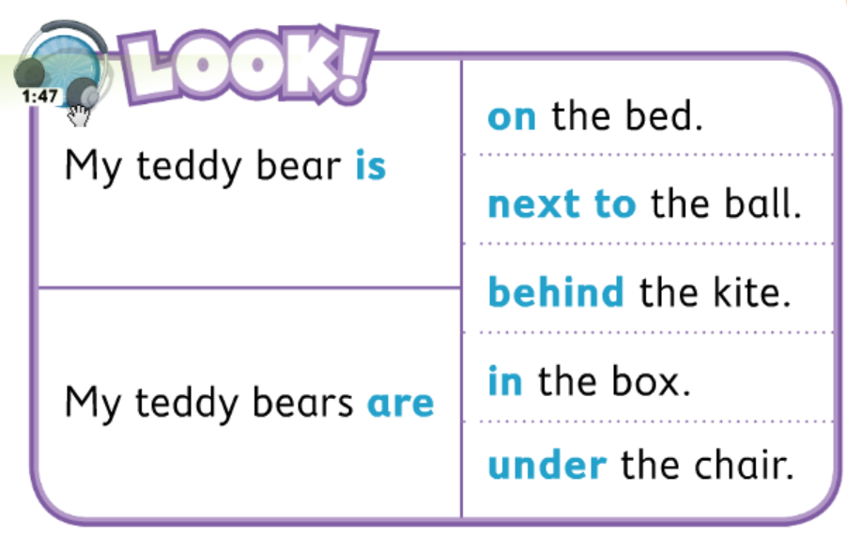

**NOW WE**

**GO ONLINE AGAIN**

**CLICK AND WORK ONLINE.**

**HS 24 B:** [**https://forms.gle/dN3gM9P3vio2Dp2t9**](https://forms.gle/dN3gM9P3vio2Dp2t9)

|  |
| --- |
| **PLEASE, PRESS “SUBMIT/SEND” AT THE END OF YOUR ONLINE WORK.**  **POR FAVOR PRESIONAR “ENVIAR” AL FINAL DEL TRABAJO EN LINEA.** |

