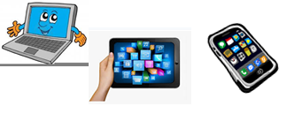

***Name:…***

***Surname: …***

***Home Schooling 25***



**WE USE PREPOSITIONS TO EXPRESS THE**

**LOCATION OF DIFFERENT ITEMS OR PEOPLE.**

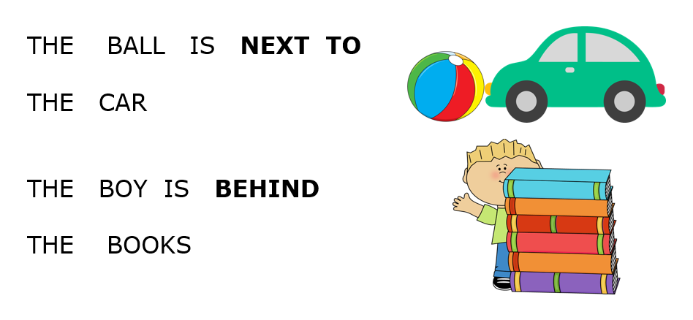

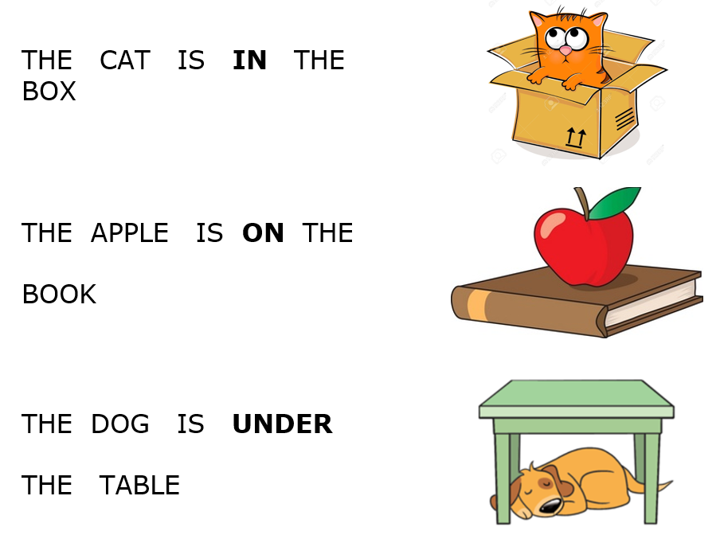

NOW GO ONLINE

**CLICK AND WORK ONLINE.**

**HS 25:** [**https://forms.gle/CDJNWjjs9hW4878g9**](https://forms.gle/CDJNWjjs9hW4878g9)

|  |
| --- |
| **PLEASE, PRESS “SUBMIT/SEND” AT THE END OF YOUR ONLINE WORK.**  **POR FAVOR PRESIONAR “ENVIAR” AL FINAL DEL TRABAJO EN LINEA.** |

**NOW CLICK ON THIS** [**LINK**](https://es.liveworksheets.com/worksheets/en/English_as_a_Second_Language_(ESL)/Prepositions_of_place/In,_on,_under_ho98802ui) **[ <https://bit.ly/2yweTWc> ] AND WORK ONLINE! WHEN YOU FINISH CLICK ON “TERMINADO” AND THEN ON “COMPROBAR MIS RESPUESTAS!**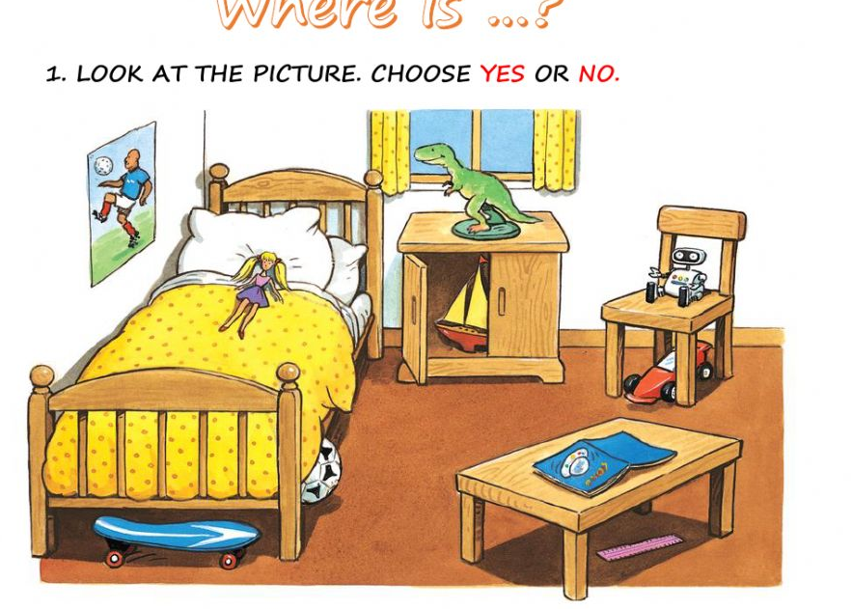

**AFTER WORKING ONLINE, COME BACK TO THIS FILE TO SOLVE OTHER EXERCISES**





|  |
| --- |
|  |
|  |

**WATCH THIS** [**VIDEO!**](https://bit.ly/3c48ejS)

<https://bit.ly/3c48ejS>

**WITH THE HELP OF YOUR FAMILY MAKE A VIDEO LIKE THIS ONE AND SEND IT TO MS MICA/MS VERO!**

**BE CREATIVE!**

**USE YOUR TOYS AND THE PREPOSITIONS: ON, IN, UNDER, BEHIND AND NEXT TO!**

