Name:…
Surname: …
Home Schooling 26

HELLO KIDS! HOW ARE YOU TODAY? WELCOME TO A NEW LESSON AND TO A NEW MONTH: JUNE!
***

***DO YOU REMEMBER THE MONTHS OF THE YEAR? HERE IS A FUN SONG FOR YOU TO LISTEN, SING AND DANCE!
PRESS CTRL + CLICK : https://bit.ly/2BfvHSt

*LET’S REVISE PREPOSITIONS! WATCH THE VIDEO AND FOLLOW THE INSTRUCTIONS!
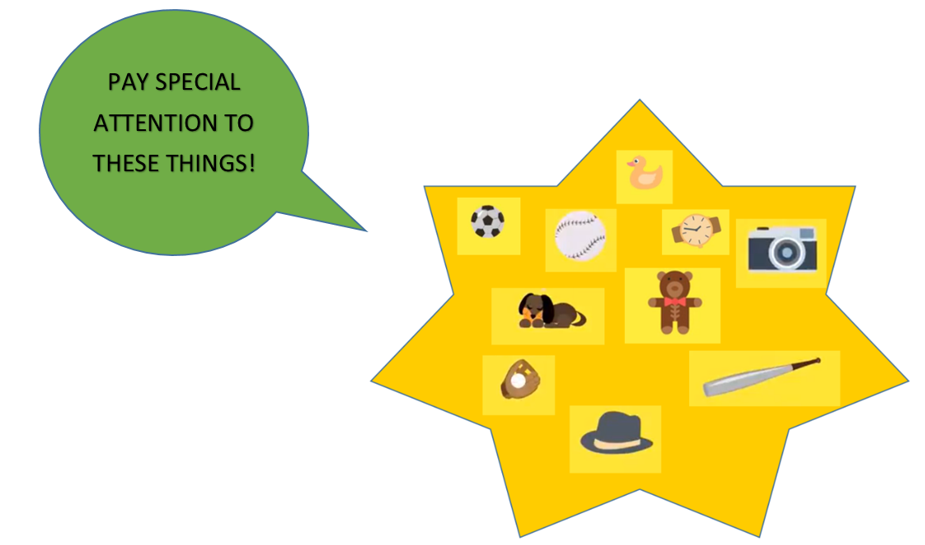
PRESS CTRL + CLICK :https://bit.ly/2XbFzoz

*HOW MANY CORRECT GUESSINGS DID YOU HAVE?
… /10

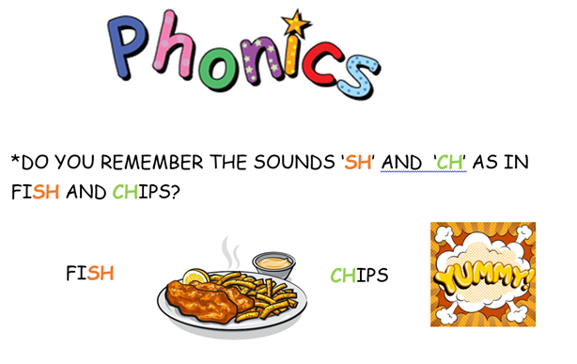
*TODAY WE’LL LEARN ABOUT TWO NEW SOUNDS:
th - th
NOW GO ONLINE

CLICK AND WORK ONLINE.
https://forms.gle/TfY5eBV7MQSyK4tC9
PLEASE, PRESS “SUBMIT/SEND” AT THE END OF YOUR ONLINE WORK.
POR FAVOR PRESIONAR “ENVIAR” AL FINAL DEL TRABAJO EN LINEA.
