Name:…
Surname: …
Home Schooling 27

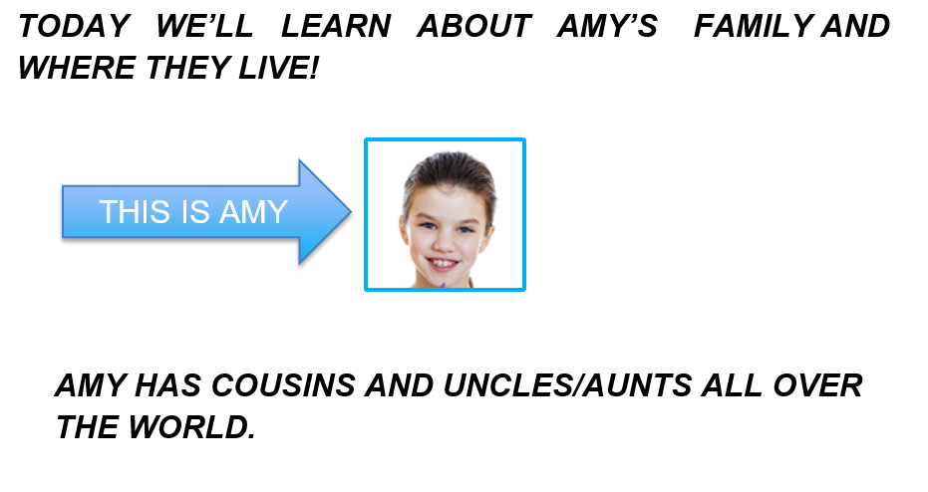
WHAT ABOUT YOU?

- HAVE YOU GOT ANY COUSINS?
… (YES, I HAVE / NO, I HAVEN’T)

- HOW MANY COUSINS DO YOU HAVE?
I’VE GOT ...

- WHERE DO THEY LIVE?
THEY LIVE IN A … (HOUSE OR FLAT?)
THESE ARE AMY’S AUNTS, UNCLES AND COUSINS!
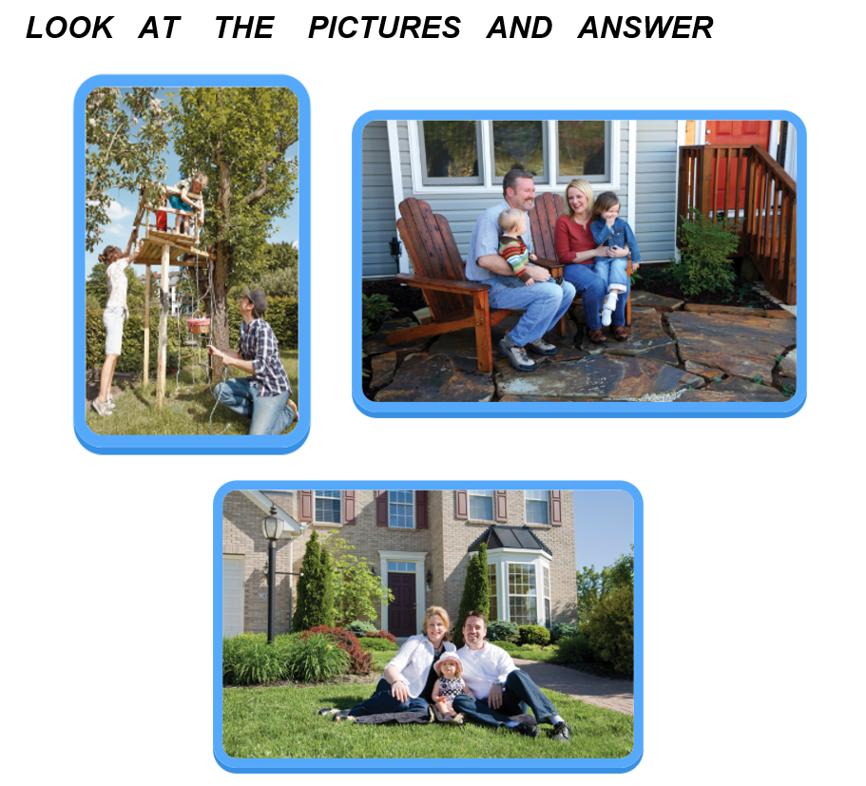
HOW MANY COUSINS HAS SHE GOT?
SHE’S GOT ... .

HOW MANY AUNTS HAS SHE GOT?
SHE’S GOT …

HOW MANY UNCLES HAS SHE GOT?
SHE’S GOT ...
LET’S GO ONLINE TO FIND OUT WHERE AMY’S FAMILY LIVE!
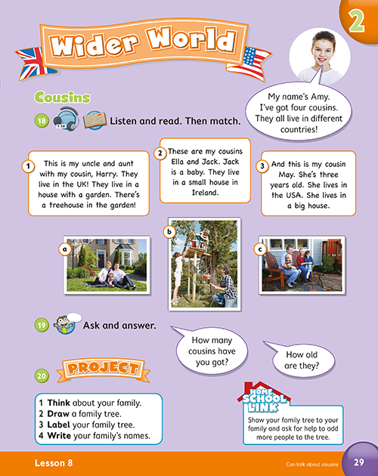

NOW GO ONLINE

CTRL+CLICK AND WORK ONLINE.
https://forms.gle/GPsXFfe4SNhviYGv7
PLEASE, PRESS “SUBMIT/SEND” AT THE END OF YOUR ONLINE WORK.
POR FAVOR PRESIONAR “ENVIAR” AL FINAL DEL TRABAJO EN LINEA.

