Name:…
Surname: …
Home Schooling 28
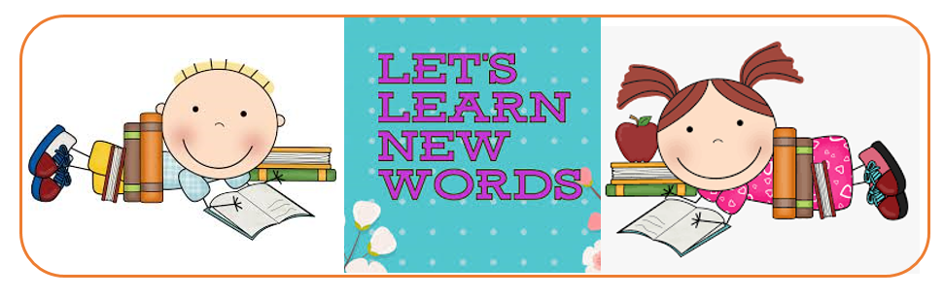

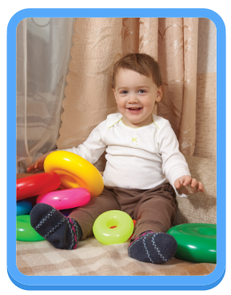
*HELLO KIDS! TODAY WE’RE LEARNING TO TALK ABOUT MORE FAMILY MEMBERS!
HAVE YOU GOT A BABY BROTHER OR SISTER?

NOW GO ONLINE

CTRL+CLICK AND WORK ONLINE.
https://forms.gle/JqWdPjSY81iMXtrk6
PLEASE, PRESS “SUBMIT/SEND” AT THE END OF YOUR ONLINE WORK.
POR FAVOR PRESIONAR “ENVIAR” AL FINAL DEL TRABAJO EN LINEA.

AFTER WORKING ONLINE, COME BACK TO THIS FILE TO SOLVE THE FOLLOWING EXERCISE

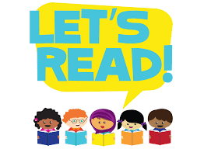

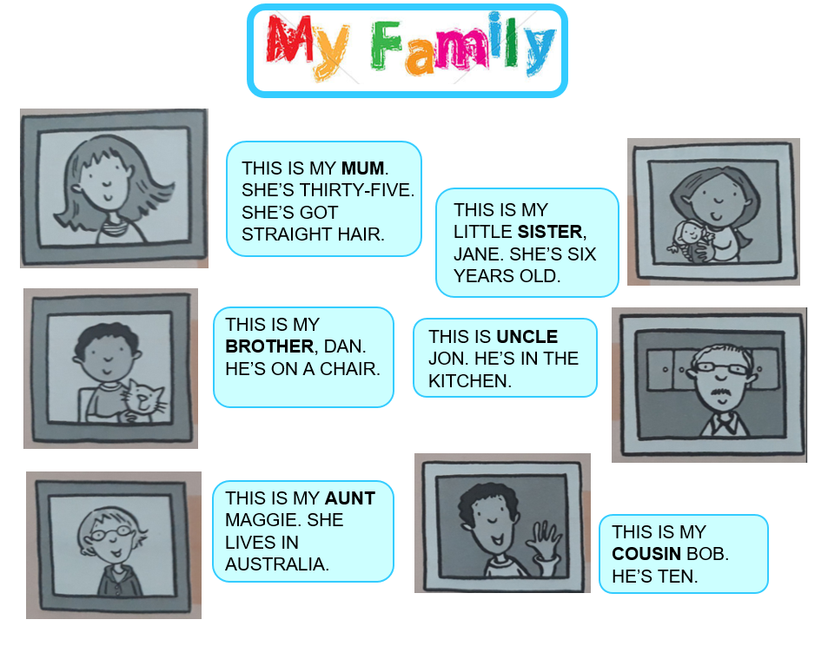
1.LOOK AND READ ABOUT GILL’S FAMILY. ANSWER THESE QUESTIONS.

*WHO IS SIX YEARS OLD? JANE IS SIX YEARS OLD.
*WHO IS TEN YEARS OLD? …
*WHO IS THIRTY-FIVE YEARS OLD? …
*WHERE IS UNCLE JON? …
*WHERE IS DAN? …

2. READ AGAIN. MATCH (COMPLETE WITH THE CORRECT WORD).

1 DAN IS GILL’S BROTHER. | AUNT.
2 MAGGIE IS GILL’S … | UNCLE.
3 BOB IS GILL’S … | BROTHER.
4 JON IS GILL’S … | SISTER.
5 JANE IS GILL’S … | COUSIN.

