Name:…
Surname: …
Home Schooling 29
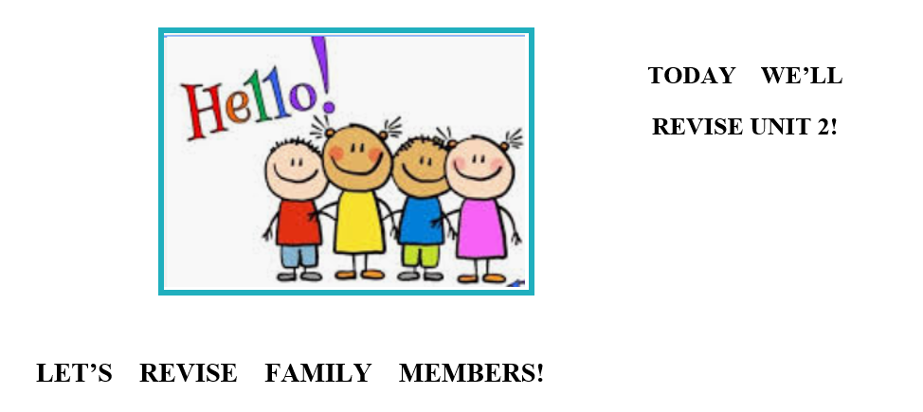
DO YOU REMEMBER THE SIMPSONS FROM THE ZOOM
MEETING? PLAY THIS GAME! https://bit.ly/3gOVcu0

…
NOW GO ONLINE
LET’S WORK ONLINE! CLICK ON THIS LINK AND ENJOY!

CTRL + CLICK AND WORK ONLINE:
https://forms.gle/jzjsddSyB7UkuctP9
PLEASE PRESS “SUBMIT/SEND” AT THE END OF YOUR ONLINE WORK.
POR FAVOR PRESIONAR “ENVIAR” AL FINAL DEL TRABAJO EN LÍNEA.

