***Name:…***

***Surname: …***



***Home Schooling 31***

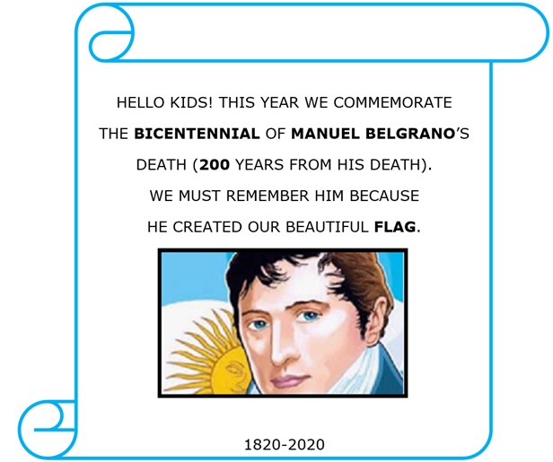

JUNE 2OTH-ARGENTINA’S FLAG DAY

**\*LISTEN AND READ THIS POEM ABOUT OUR FLAG.**

|  |
| --- |
| smiley small Press ctrl and click to listen to the audio file: |

<https://bit.ly/2ANLDuW>

A POEM: I LOVE MY FLAG

WITH BLUE AND WHITE STRIPES,

AND A YELLOW SUN,

THIS IS THE FLAG

I LOVE VERY MUCH!

FOR ME IT’S BEAUTIFUL,

FOR ME IT’S GREAT,

AND I JUST LOVE IT,

DAY AFTER DAY!

**\*ANSWER THESE QUESTIONS ABOUT THE POEM.**

1. **HOW MANY** **STRIPES** (LINES) **HAS THE FLAG GOT? …**

2. **WHAT COLOUR** **ARE THE STRIPES? …**

3. **IS** **THE SUN ORANGE? …**

**\*WATCH THIS VIDEO! DRAW AND COLOUR/DECORATE THE FLAG! SEND US THE PICTURE! YOU CAN USE PAINT, MARKERS, GLITTER GLUE/PAPER, WHATEVER YOU WANT.**

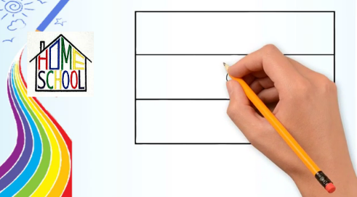

**CTRL + CLICK TO WATCH THE VIDEO:**

[**https://bit.ly/2YgxWMX**](https://bit.ly/2YgxWMX)

**\*NOW, GO ONLINE**

<https://www.liveworksheets.com/sy796393ua>

**OPTIONAL ACTIVITY!** IF YOU HAVE A PRINTER, YOU CAN PRINT AND COLOUR; OR DRAW AND COLOUR!



