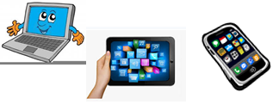

***Name:…***

***Surname: …***

***Home Schooling 34***



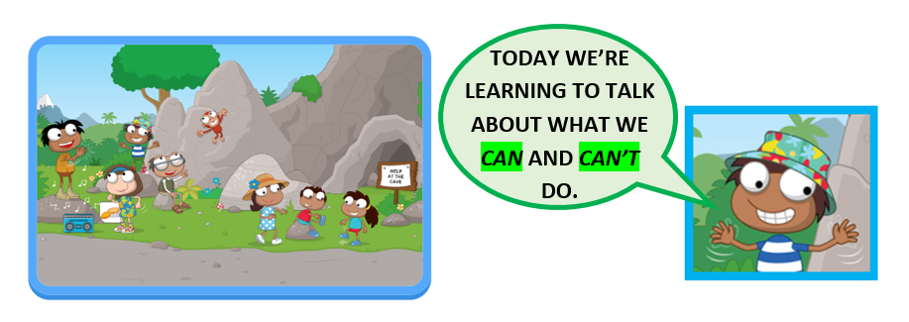

*Let’s play this game to revise body movements!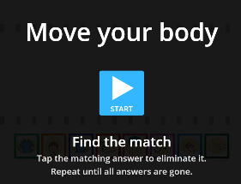

**CTRL + CLICK**

<https://wordwall.net/play/2942/848/699>

*Watch this video! 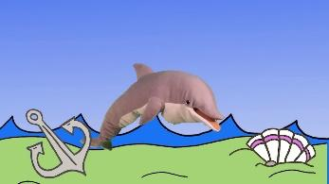

**CTRL + CLICK**

<https://www.youtube.com/watch?v=oCAZMW4jMX8>

*WATCH THIS VIDEO YOUR TEACHERS HAVE RECORDED FOR YOU!

 <https://bit.ly/2V9D1pu>





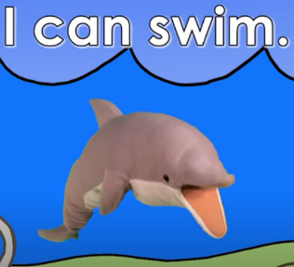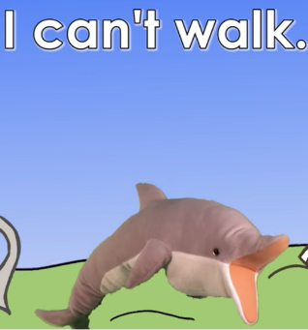

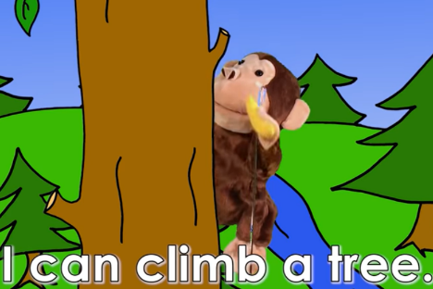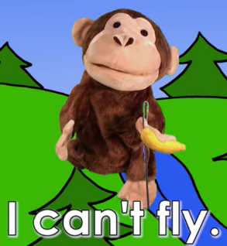



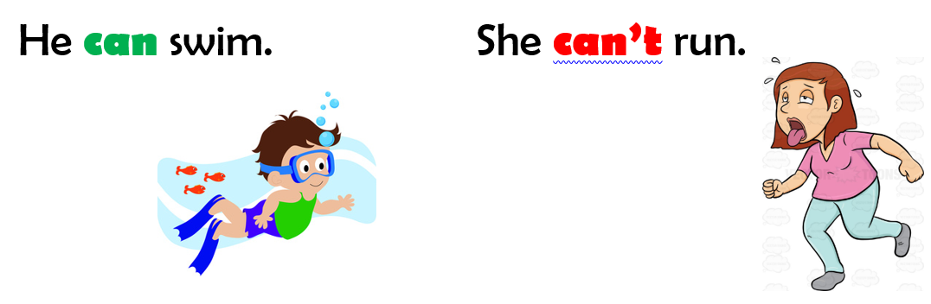

NOW GO ONLINE

**CTRL + CLICK AND WORK ONLINE**

**<https://forms.gle/akpupbi6rX5wYCD58>**

