Name:…
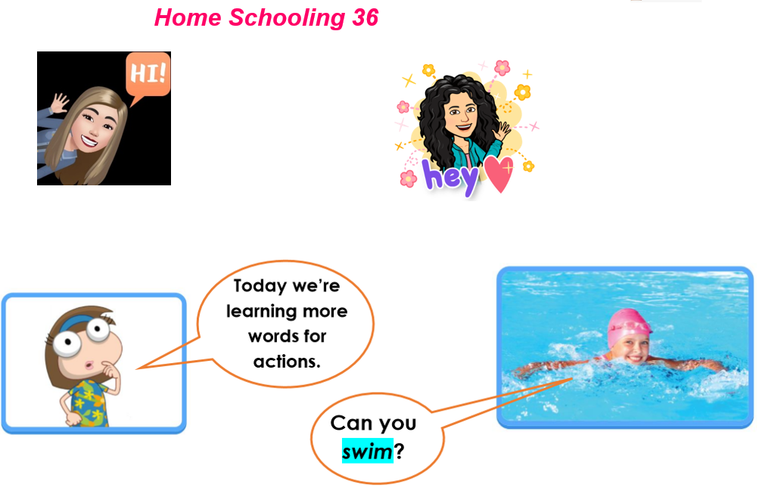
Surname: …
*PART 1
-Complete the three activities in this sheet.
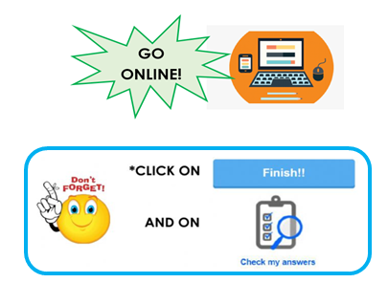
PRESS CTRL+CLICK https://www.liveworksheets.com/oa859844ot
…

*PART 2

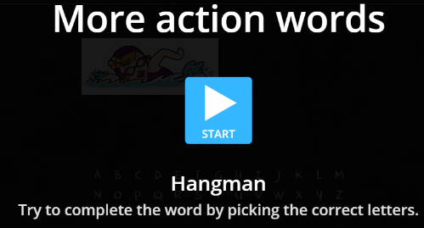
-Let’s play Hangman!

…
PRESS CTRL+CLICK
https://wordwall.net/play/3034/567/785

*PART 3
NOW WE
GO ONLINE AGAIN

PRESS CTRL+CLICK AND WORK ONLINE:
https://forms.gle/kB7LmfLWxcQc5tY8A
PLEASE PRESS “SUBMIT/SEND” AT THE END OF YOUR ONLINE WORK.
POR FAVOR PRESIONAR “ENVIAR” AL FINAL DEL TRABAJO EN LINEA.

