Name:…
Surname: …
Home Schooling 37

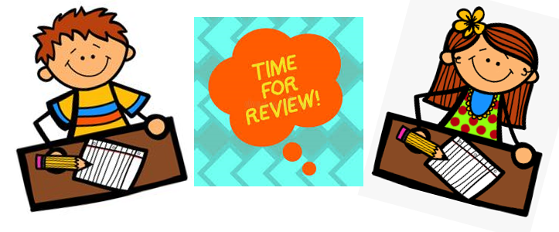

*HERE ARE FOUR ACTIVITIES FOR YOU TO PRACTISE AND HAVE FUN! ENJOY!

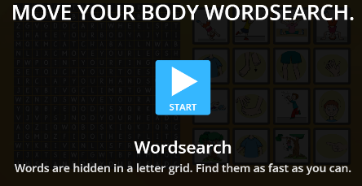
- MOVE YOUR BODY WORDSEARCH.
PRESS CTRL+CLICK
https://wordwall.net/play/3044/447/405
…

- ACTION WORDS. MATCH AND WRITE THE MISSING LETTERS.

PRESS CTRL+CLICK
https://www.liveworksheets.com/to864089ou
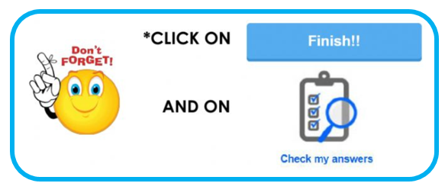
…
…

…

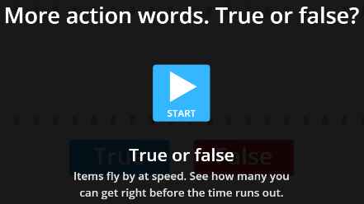
- MORE ACTION WORDS. TRUE OR FALSE?

PRESS CTRL+CLICK
https://wordwall.net/play/3044/378/314

- MORE ACTION WORDS. DRAG AND DROP TO MAKE CORRECT SENTENCES.

PRESS CTRL+CLICK
https://www.liveworksheets.com/pq864446lu
…

