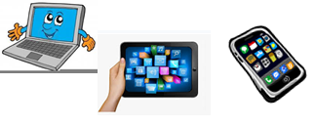
Name:…
Surname: …
Home Schooling 38

LET’S REVISE WHAT WE LEARNT AT THE
ZOOM LESSON!
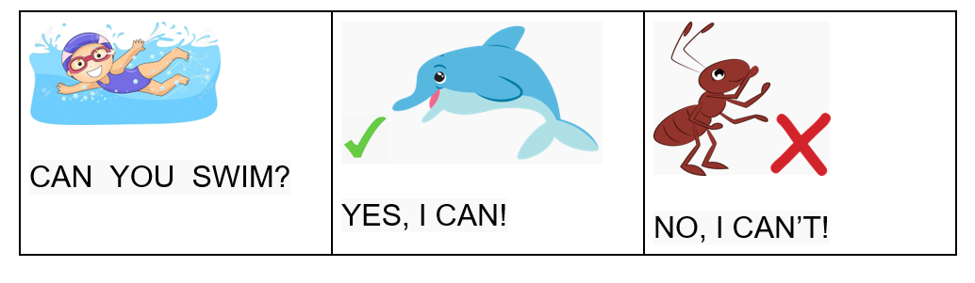

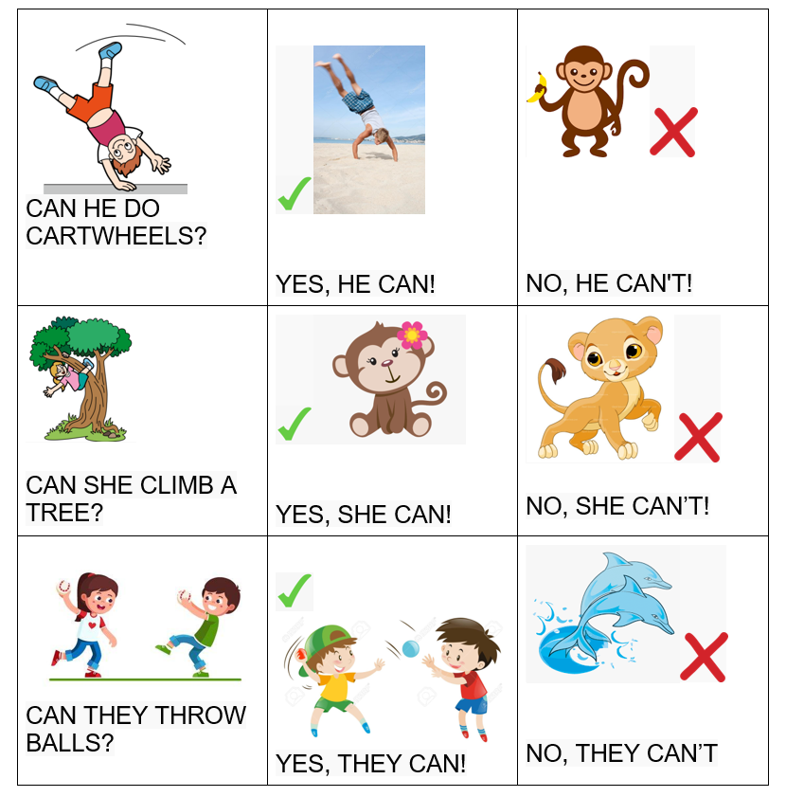

WHEN WE ASK, WE CHANGE THE ORDER OF THE

SENTENCE. DON’T FORGET TO ADD THE QUESTION

MARK (?)

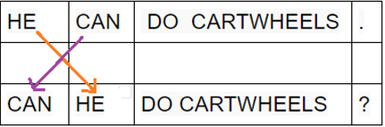

- LET’S FIND OUT WHAT THESE ANIMALS CAN DO!
CLICK ON THIS LINK https://www.liveworksheets.com/pz884631pz
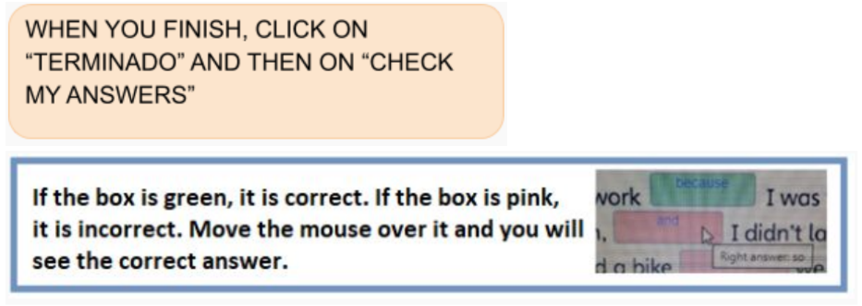

- DO THIS QUIZ! https://es.educaplay.com/recursos-educativos/6218818-animals.html
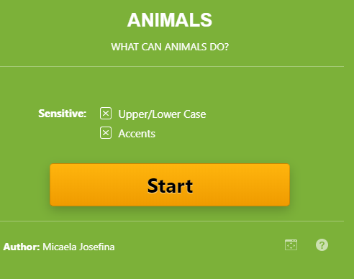
NOW WE
GO ONLINE AGAIN

PRESS CTRL+CLICK AND WORK ONLINE:
https://forms.gle/RaPFfhe7bcnDzSik9
PLEASE PRESS “SUBMIT/SEND” AT THE END OF YOUR ONLINE WORK.
POR FAVOR PRESIONAR “ENVIAR” AL FINAL DEL TRABAJO EN LÍNEA.

