Name:…
Surname: …
Home Schooling 39

LET’S FIND OUT WHAT CHARLIE, ROSIE AND OLA ARE DOING!
NOW GO ONLINE

- CTRL + CLICK TO GO ONLINE!
https://forms.gle/qNQYc5jE5GU1kvtk6

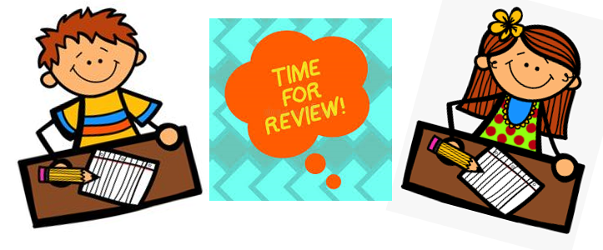
- LET’S REVISE ACTIONS!
https://wordwall.net/es/resource/3181452 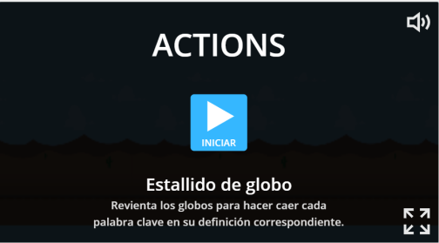

- ANSWER THESE QUESTIONS.

  - CAN YOU DO THE SPLITS?

...

  - CAN YOU DO CARTWHEELS?

...

  - CAN YOU SWING?

...

  - CAN YOU NOD YOUR HEAD?

...

- COMPLETE FOR YOURSELF WITH √ OR X . THEN, ASK A FRIEND.

 | SWIM | DO CARTWHEELS | STAND ON YOUR HEAD
ME | √ | … | …
MY FRIEND | … | … | …

- WRITE ABOUT YOU AND YOUR FRIEND.

I CAN SWIM. | I CAN’T …
MY FRIEND CAN … | HE / SHE CAN’T …
NOW WE
GO ONLINE AGAIN

- CTRL + CLICK TO GO ONLINE!
https://forms.gle/J9C8XYQ6Tw4zNF9N6

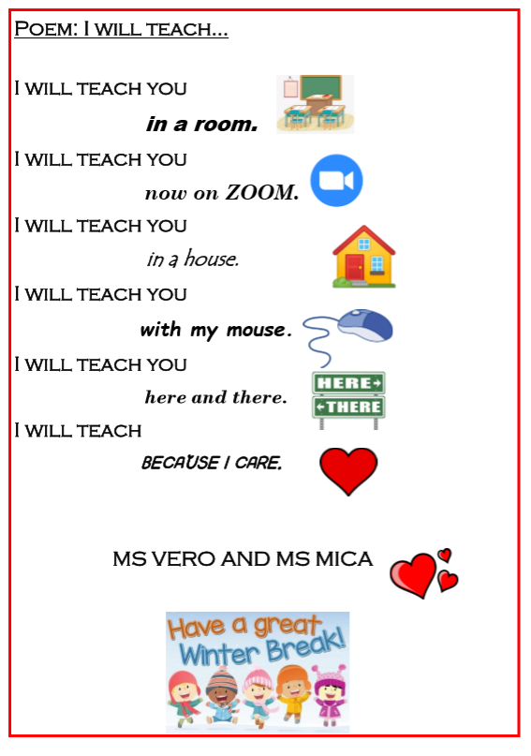

ENJOY! HAPPY WINTER HOLIDAYS!

