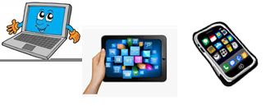
Name:…
Surname: …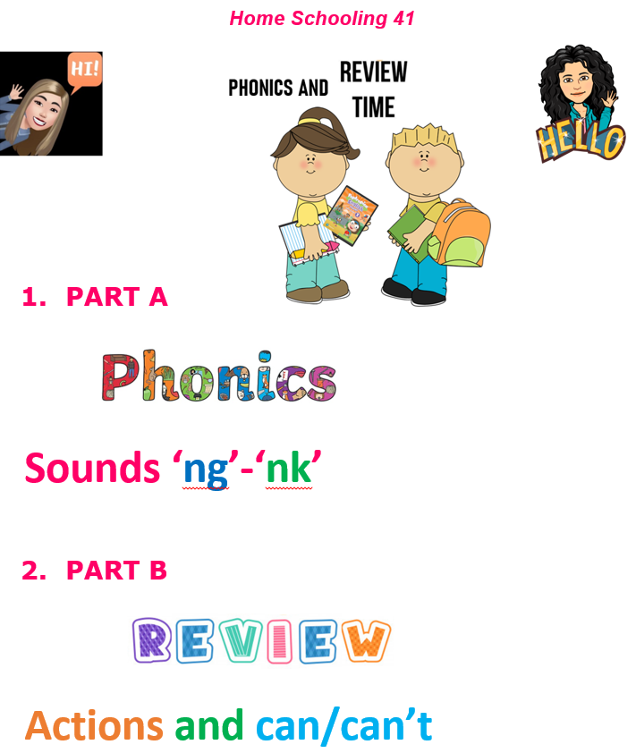
NOW GO ONLINE

CTRL + CLICK TO GO ONLINE!
PART A: https://forms.gle/bidhK6yX9FTfHc1s6
PART B: https://forms.gle/LF4osAaqQe7qqNnd8
