***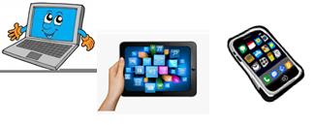***

***Name: …***

***Surname: …***

**

***Home Schooling 42***

1. **CTRL + CLICK TO PLAY THIS GAME TO REVISE!**

[**https://wordwall.net/es/resource/3571962**](https://wordwall.net/es/resource/3571962)

1. **DO THIS WORKSHEET!** [**https://www.liveworksheets.com/io1003588na**](https://www.liveworksheets.com/io1003588na)

****

NOW GO ONLINE

**CTRL + CLICK TO GO ONLINE!**

**[https://forms.gle/QhX9PWGEae9sqK237](https://forms.gle/QhX9PWGEae9sqK237" \t "_blank)**





