Name: …
Surname: …
Home Schooling 43

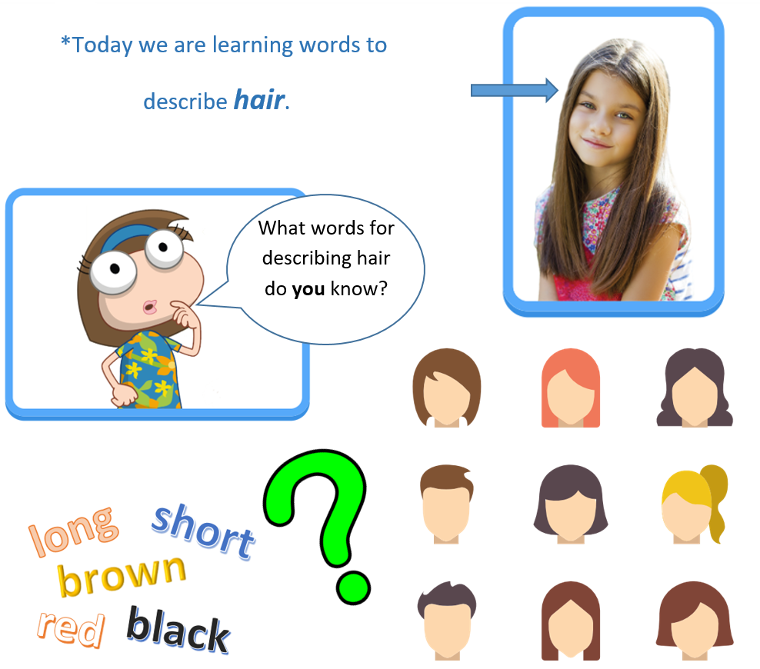

- LET’S LEARN! DO THIS WORKSHEET.
https://www.liveworksheets.com/gz1007724tc
NOW GO ONLINE

CTRL + CLICK TO GO ONLINE!
https://forms.gle/dViJ1ZfixQnW1a7d7

