Name : …
Surname: …
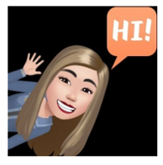
Home Schooling 44

*DO YOU REMEMBER THESE WORDS TO DESCRIBE HAIR?
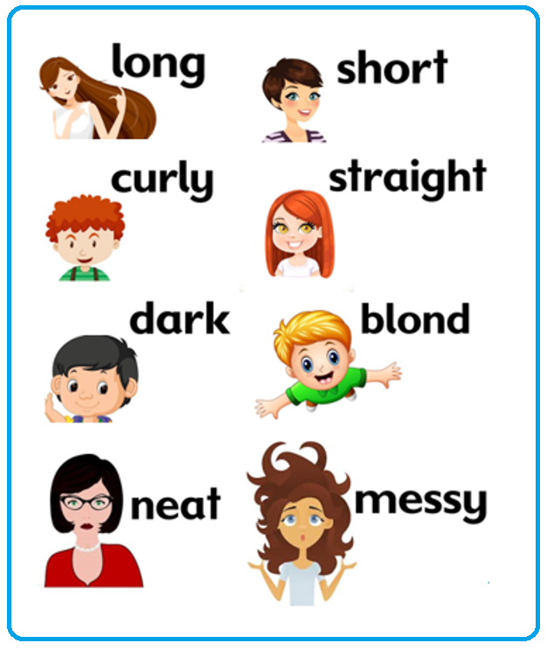

*LET’S PLAY SOME GAMES TO PRACTISE!
-PRESS CTRL+CLICK AND HAVE FUN!
MEMOTEST
https://www.educaplay.com/learning-resources/6518653-words_to_describe_hair.html
TRUE OR FALSE?
https://wordwall.net/play/3617/480/519
HANGMAN
https://wordwall.net/play/3617/711/675

*LET’S LEARN ABOUT THE FIVE SENSES!
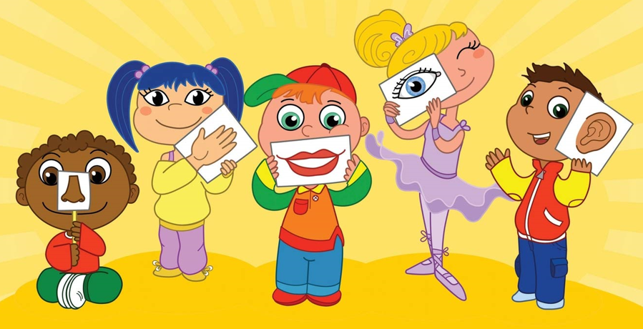

*DO THIS WORKSHEET! PRESS CTRL+CLICK
https://www.liveworksheets.com/tx1017126ul
NOW GO ONLINE

CTRL + CLICK TO GO ONLINE!
https://forms.gle/JfJ32fEGo22DYU5F7
