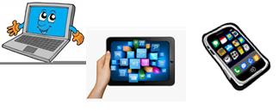
Name: …
Surname: …
Home Schooling 45

- LET’S REVISE!
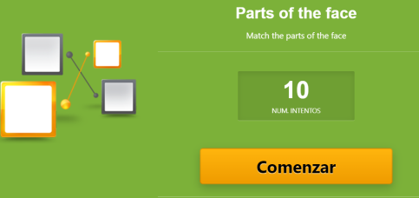
https://es.educaplay.com/recursos-educativos/5995400-parts_of_the_face.html

- DO THESE LIVEWORKSHEETS!

https://www.liveworksheets.com/mj655047kk
https://www.liveworksheets.com/ak95822nr
WHEN YOU FINISH CLICK ON
“FINISH” AND THEN ON “CHECK
MY ANSWERS”

NOW GO ONLINE
CTRL + CLICK TO GO ONLINE!
https://forms.gle/usr2eHfV1qhRufRW9
PLEASE PRESS “SUBMIT/SEND” AT THE END OF YOUR ONLINE WORK.
POR FAVOR PRESIONAR “ENVIAR” AL FINAL DEL TRABAJO EN LINEA.

