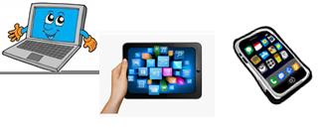

***Name:…***

***Surname: …***

***Home Schooling 46***

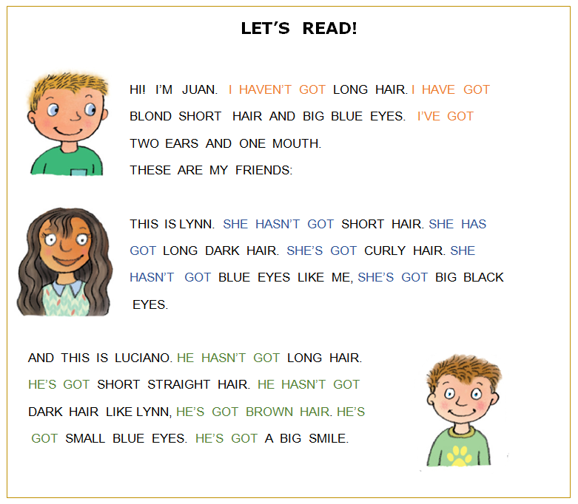

1. **ANSWER “TRUE” OR “FALSE”!**

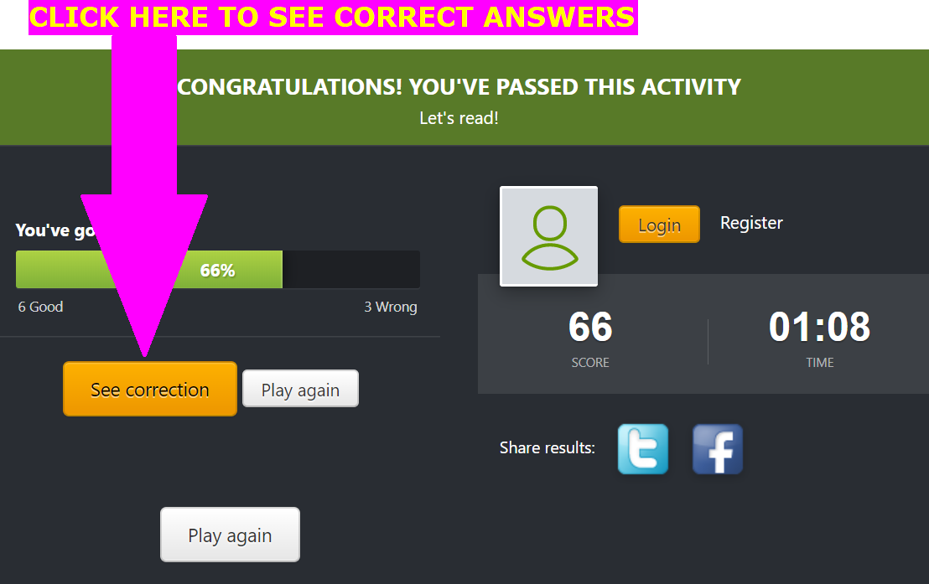<https://es.educaplay.com/recursos-educativos/6619222-let_s_read.html>

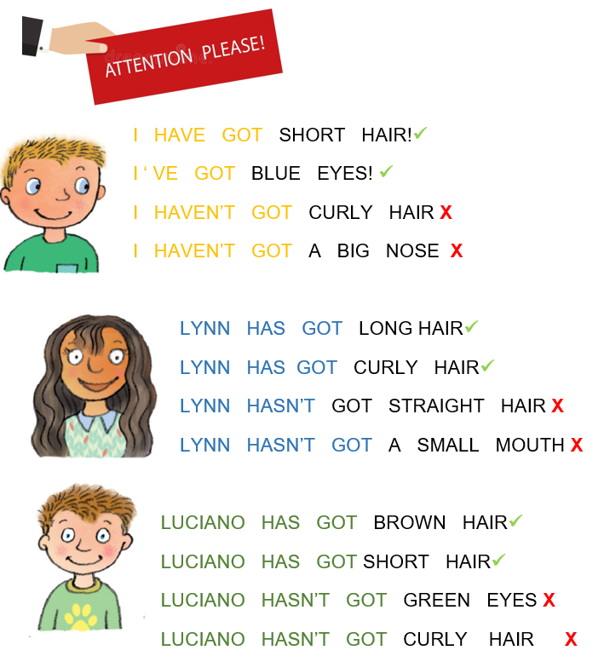

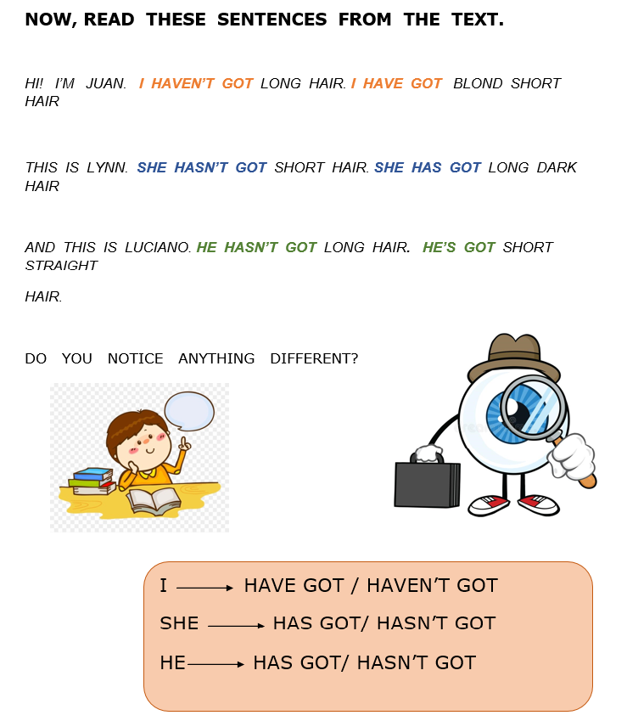

NOW GO ONLINE

**CTRL + CLICK TO GO ONLINE!**

[**https://forms.gle/euEMbyRTg2gx31Sp8**](https://forms.gle/euEMbyRTg2gx31Sp8)





