NOW GO ONLINE

CTRL + CLICK TO GO ONLINE!
https://forms.gle/aSyLYMkyrhPaSRQs5
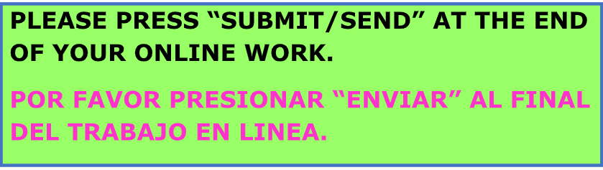

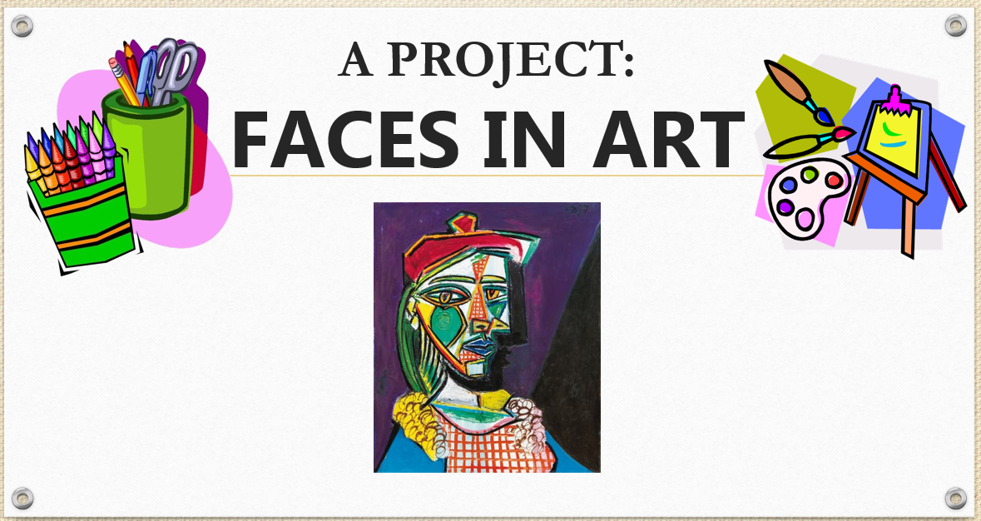

LET’S MAKE A PICASSO FACE
TO SHARE ON ZOOM

- DO YOU KNOW THE FAMOUS SPANISH ARTIST PABLO PICASSO?
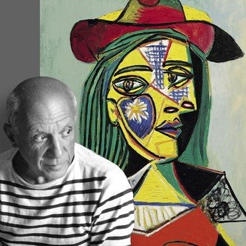

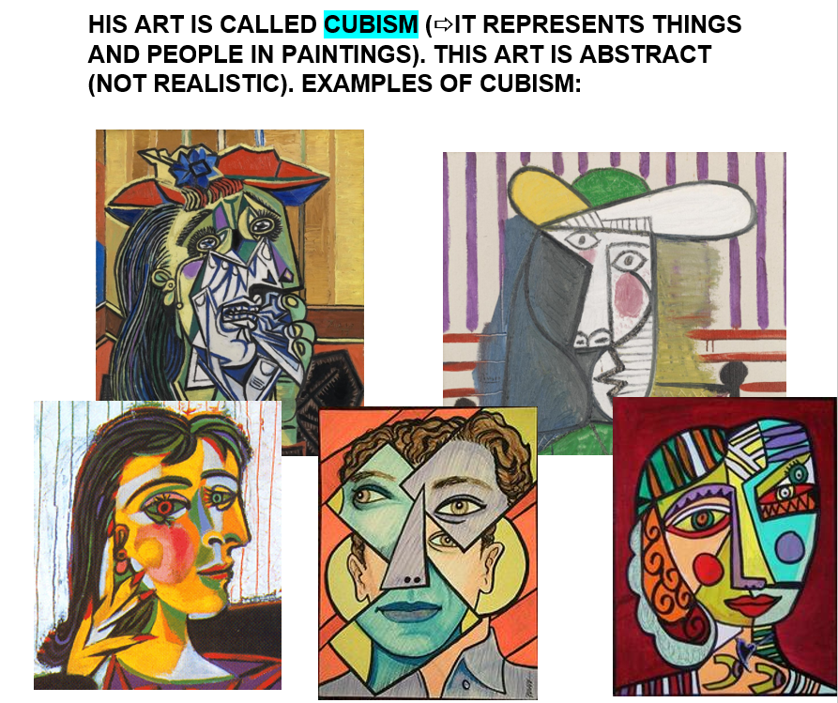

- GET READY!

WATCH THIS VIDEO TO GET SOME IDEAS.
https://bit.ly/2Eg4q3A
LOOK AT THESE EXAMPLES OF MASKS AND CREATE YOUR OWN ‘PICASSO FACE’.
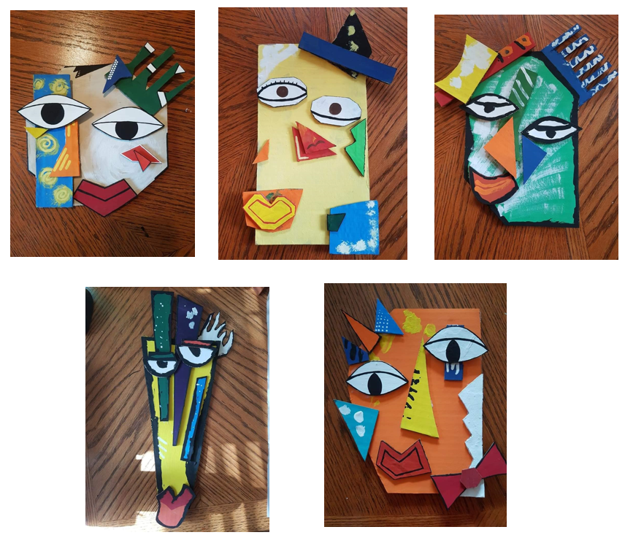

YOU CAN USE THE MATERIALS YOU LIKE, CRAYONS, MARKERS, PAINT, ETC.

PAY ATTENTION TO THE SHAPES.
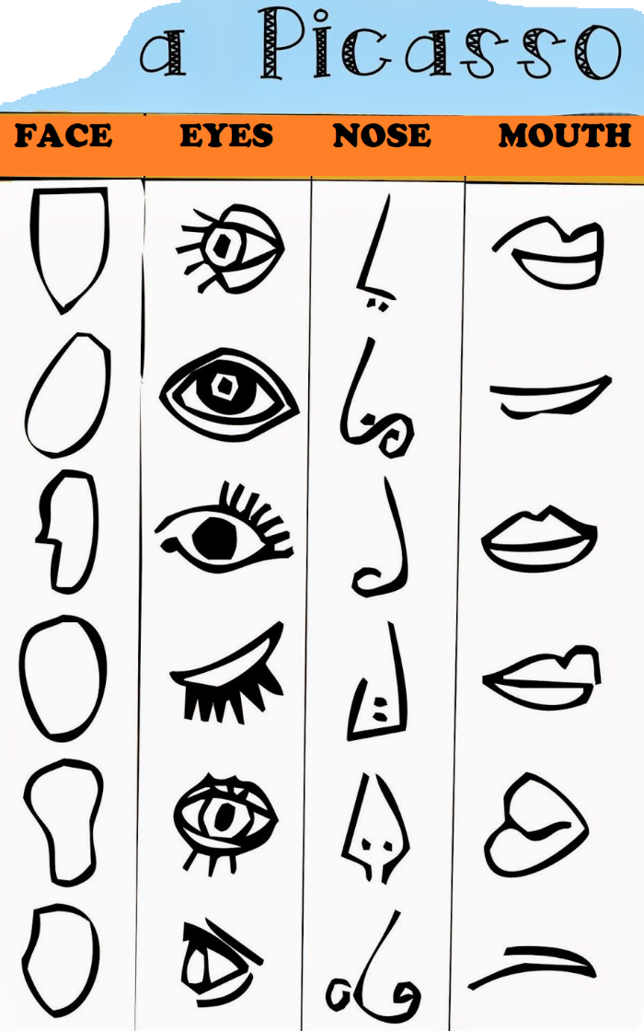

- HANDS ON! USE ALL YOUR CREATIVITY TO MAKE A PICASSO MASK.

- SHARING DATE: SEPTEMBER 1ST - 2ND ON ZOOM.

