Name:…
Surname: …
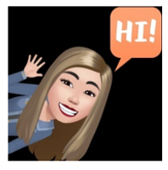
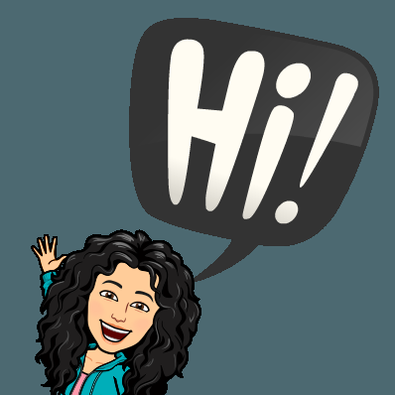
Home Schooling 48

- DO THIS WORKSHEET!

https://www.liveworksheets.com/jo1091703kx

WHEN YOU FINISH CLICK ON
“FINISH” AND THEN ON “CHECK
MY ANSWERS”

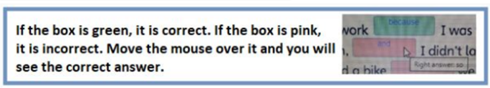

- LOOK AT THE PICTURES AND COMPLETE. USE THESE WORDS:

HAVE GOT - HAVEN’T GOT - HAS GOT - HASN’T GOT

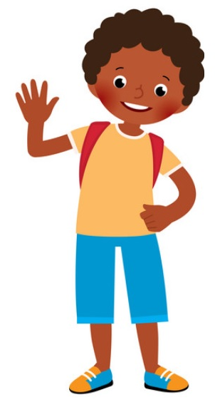
HI! I’M JIM.
I ... LONG DARK HAIR. I ... BLOND HAIR.
I ... CURLY HAIR.
I ... DARK EYES.

THESE ARE MY FRIENDS:

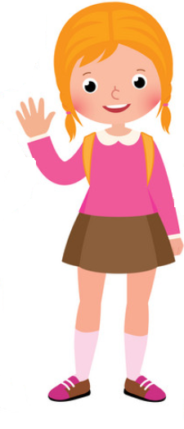
THIS IS PAULA.
PAULA ... BLOND HAIR.
SHE ... CURLY HAIR. SHE ... STRAIGHT HAIR.
SHE ... BIG EYES

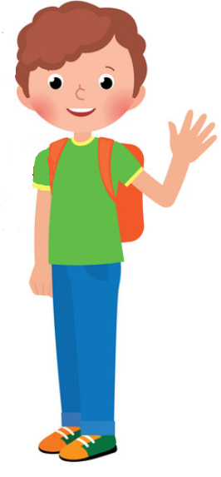

AND THIS IS TOBY!
HE ... SHORT CURLY HAIR
HE ... BROWN HAIR
HE ... BLUE EYES. HE... DARK EYES.

