Name:…
Surname: …

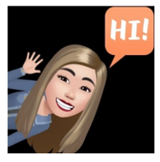
Home Schooling 49
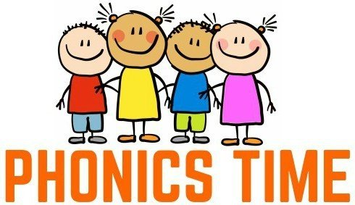

*HELLO KIDS! TODAY WE’RE LEARNING TWO NEW SOUNDS. DO YOU REMEMBER THE ‘NG’ AND ‘NK’ SOUNDS FROM UNIT 3?

CTRL + CLICK AND PLAY THIS MEMO GAME!
https://www.educaplay.com/game/6617590-phonics_review.html
NOW GO ONLINE

CTRL + CLICK TO GO ONLINE!
https://forms.gle/iZFnFWshHTEVgyJt8
