***Name: …***

***Surname: …***

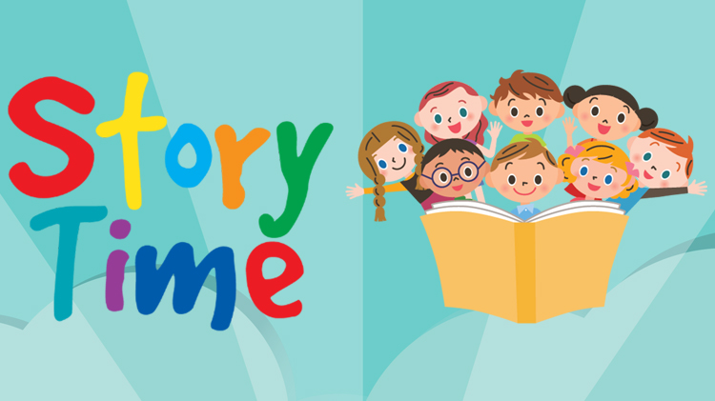***Home Schooling 50***

**\*LET’S READ A NEW STORY ABOUT CHARLIE, ROSE AND OLA!**



NOW GO ONLINE

**CTRL + CLICK TO GO ONLINE!**

[**https://forms.gle/qwZqg6vJyUsHwNBd9**](https://forms.gle/qwZqg6vJyUsHwNBd9)





