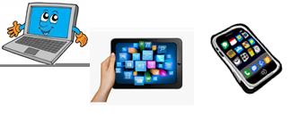
Name: …
Surname: …
Home Schooling 55
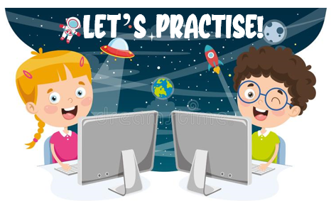

LET’S GO TO SPACE TO VISIT THE COLOUR PLANETS!
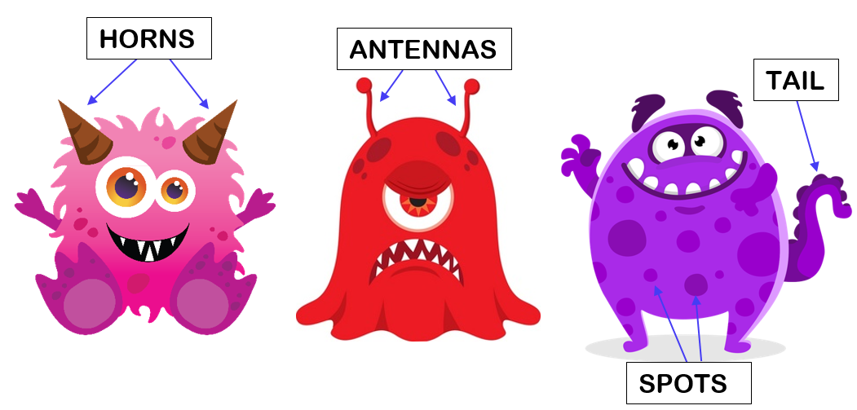
*READ AND CLICK ON THE RIGHT SPACE MONSTER.
HAVE FUN!
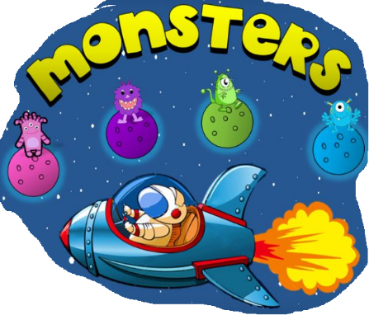

CTRL+ CLICK
https://bit.ly/2FmD645

*NOW, DO THESE WORKSHEETS!
CTRL + CLICK
https://www.liveworksheets.com/hk139934qp
https://www.liveworksheets.com/ns735320sk
NOW GO ONLINE

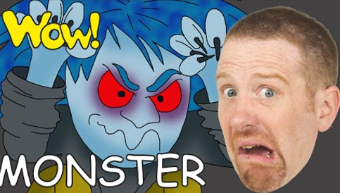
*GO ONLINE TO RIDE ON THE MONSTER TRAIN!
CTRL +CLICK TO GO ONLINE
https://forms.gle/UsWufScPMwbABTBo7
