Name: …
Surname: …
Home Schooling 56
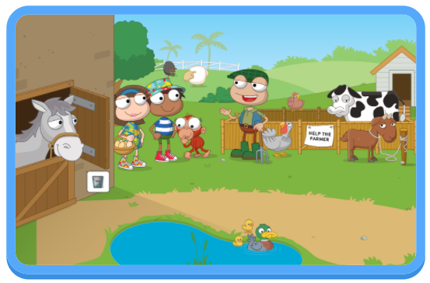

*TODAY WE’LL START A NEW UNIT. LET’S DO SOME REVISION.
CTRL + CLICK
https://wordwall.net/play/4290/791/483

*LET’S LEARN ABOUT FARM ANIMALS! CAN YOU DO THIS JIGSAW PUZZLE?
CTRL + CLICK
https://www.jigsawplanet.com/?rc=play&pid=1e610af634a6
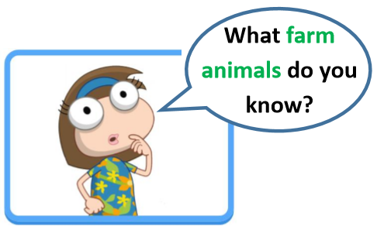

NOW GO ONLINE

CTRL + CLICK TO GO ONLINE
https://forms.gle/Nxn789XryRY1x8KAA
