Name: …
Surname: …
Home Schooling 58
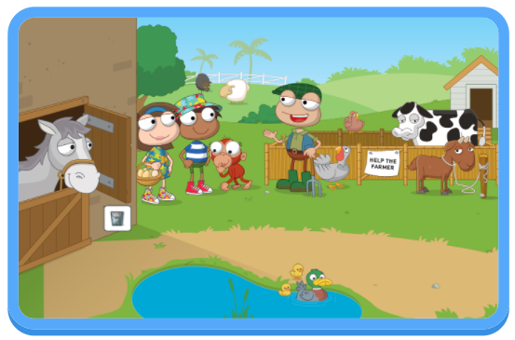

*LET’S REVISE FARM ANIMALS!
NOW GO ONLINE

CTRL + CLICK TO GO ONLINE
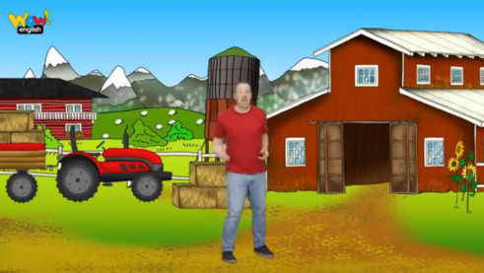
HOME SCHOOLING 58 A: https://forms.gle/yBZA1L97qYrgayky7

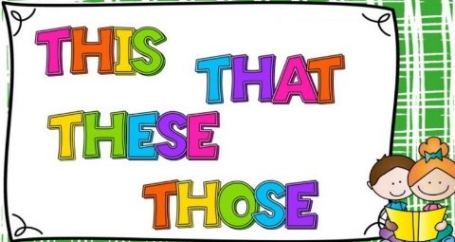
HOME SCHOOLING 58 B: https://forms.gle/fA6bg6Tkod6qb5kL6

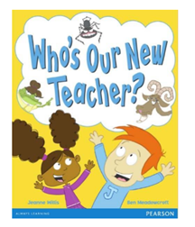
HOME SCHOOLING 58 C: https://forms.gle/9mLweyaX5pmxy3RT8

