Name: …
Surname: …
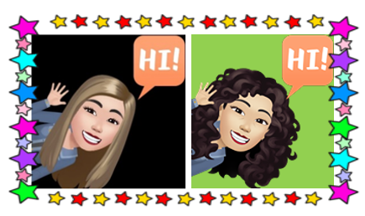
Home Schooling 61

TODAY WE’RE LEARNING WORDS FOR WILD ANIMALS.

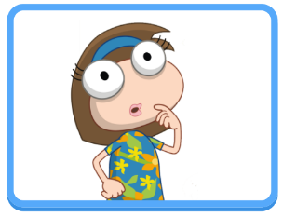

NOW GO ONLINE

CTRL + CLICK TO GO ONLINE
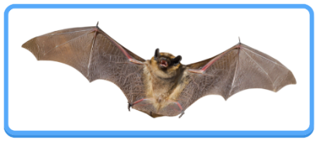
HOMESCHOOLING 61 A: https://forms.gle/EfopD5snNgew4DSy9
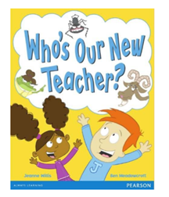
HOMESCHOOLING 61 B: https://forms.gle/oETLyLPDGVYYgPc19

