

***Name: …***

***Surname: …***

***Home Schooling 63***

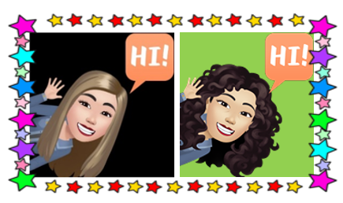

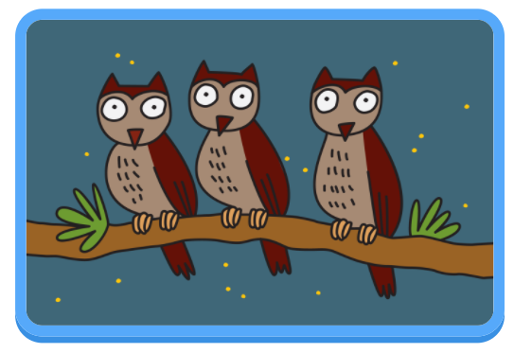

**TODAY WE’RE LEARNING TO ASK AND ANSWER MORE QUESTIONS ABOUT ANIMALS.**



**CTRL + CLICK TO GO ONLINE**

[**https://forms.gle/zz88AxXSMtGf3v8u7**](https://forms.gle/zz88AxXSMtGf3v8u7)

