Name: …
Surname: …
Home Schooling 66
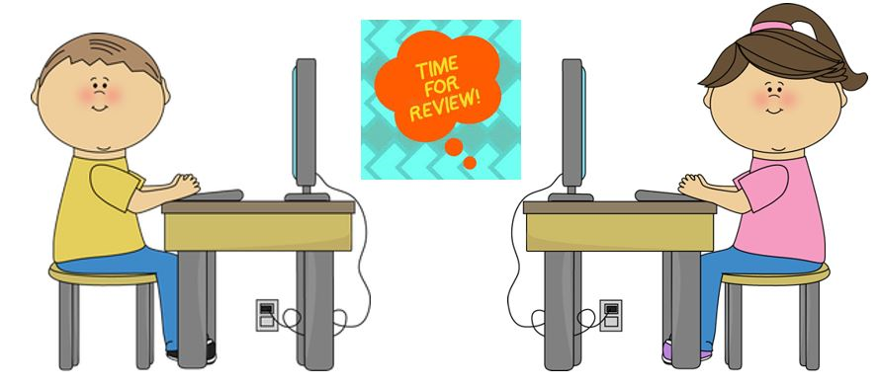

NOW GO ONLINE

CTRL + CLICK TO GO ONLINE
HOMESCHOOLING 66 : https://forms.gle/akChzpJ8sLReaVJh9

