

***Name: …***

***Surname: …***

***Home Schooling 67***



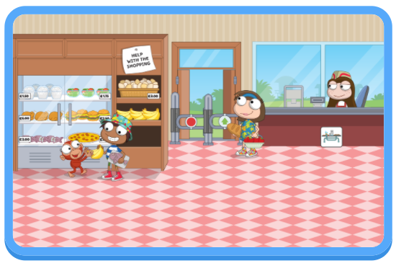



NOW GO ONLINE

**CTRL + CLICK TO GO ONLINE :**

[**https://forms.gle/87AB3aqcYKQhfgcp8**](https://forms.gle/87AB3aqcYKQhfgcp8)

