***Name: …***

***Surname: …***

***Home Schooling 71***

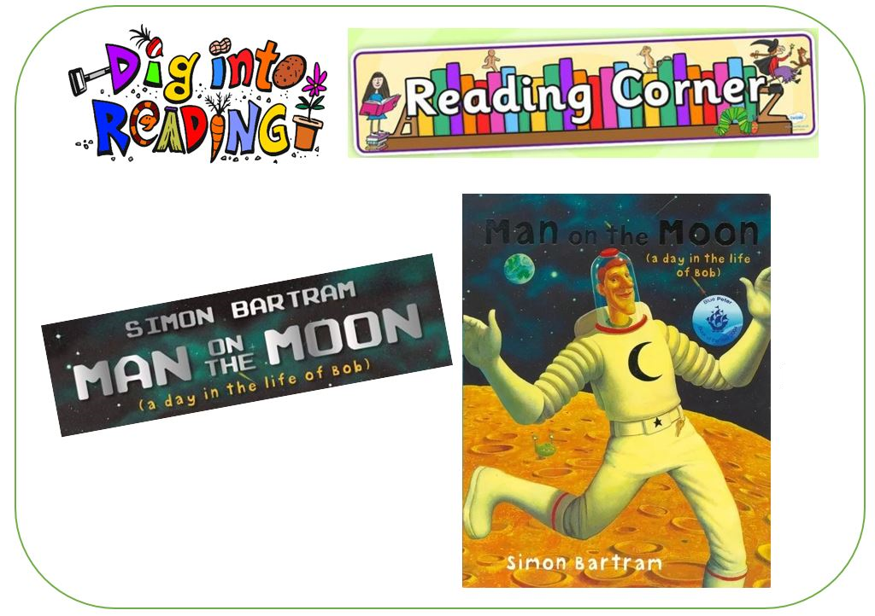

***LET’S LEARN***

***MORE FOOD WORDS!***





**CTRL + CLICK TO GO ONLINE :**

[**https://forms.gle/T9JQbutp4berFshAA**](https://forms.gle/T9JQbutp4berFshAA)

