Name:…
Surname: …
Home Schooling 10
- Hi there! Let’s keep working!

- Find the simple past form of the verbs in the word search. (Follow the link and play online) Then, complete the chart.
https://thewordsearch.com/puzzle/962787/simple-past-verbs/

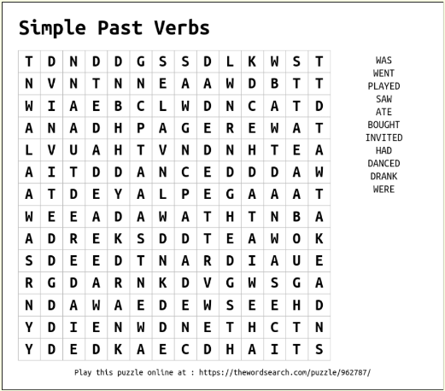
be | …
have | …
dance | …
buy | …
go | …
invite | …
drink | …
eat | …
play | …
see | …

- Getting ready for a song!
These verbs appear in the song “Paradise” (Coldplay). Match the past form.
expected
flew
ran
dreamed /dreamt
closed

Infinitive | Past
close | …
dream | …
fly | …
run | …
expect | …

- Complete the song using the past simple verbs from the chart in exercise 2.

Paradise by Coldplay
When she was just a girl
She 1… the world
But it 2… away from her reach
So she 3… away in her sleep
And 4… of paradise
Paradise, paradise, Paradise (x2)
Every time she 5… her eyes

When she was just a girl
She 6… the world
But it 7… away from her reach
And the bullets catch in her teeth
Life goes on, gets so heavy
The wheel breaks the butterfly
Every tear a waterfall
In the night, the stormy night
She'd close her eyes
In the night, the stormy night
Away she'd fly

And dreams of paradise
Paradise, paradise, Paradise, oh
And dreams of paradise
Paradise, paradise, paradise, oh

So lying underneath the stormy skies
She'd say, oh
'I know the sun will set to rise'
This could be paradise
Paradise, paradise
Could be paradise, oh

- Now, let’s have fun! Listen, play and sing! (You don’t need to create an account, press “Quizás en otro momento”)
https://es.lyricstraining.com/play/coldplay/paradise/HxsilzhURx#b7w
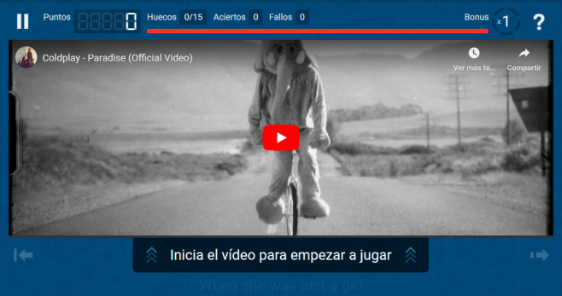

Did you like this singing activity? …

- Now choose 3 verbs from exercise 2 and write a very short story, paragraph or poem. Be creative!
Last Saturday
A boy/ girl
A woman/ man
In the night/ morning
A sunny/stormy day

…

This is the end of your file. Check you have solved all the activities, save your work and send it to your teacher via email:
4th Girls and Boys: msgabygar@gmail.com

