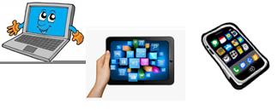
Name:…
Surname: …
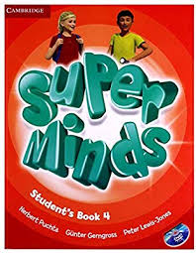
Home Schooling 11
Hello! Today we start working on UNIT 1 of SUPERMINDS 4.

- Let’s revise CLOTHES.

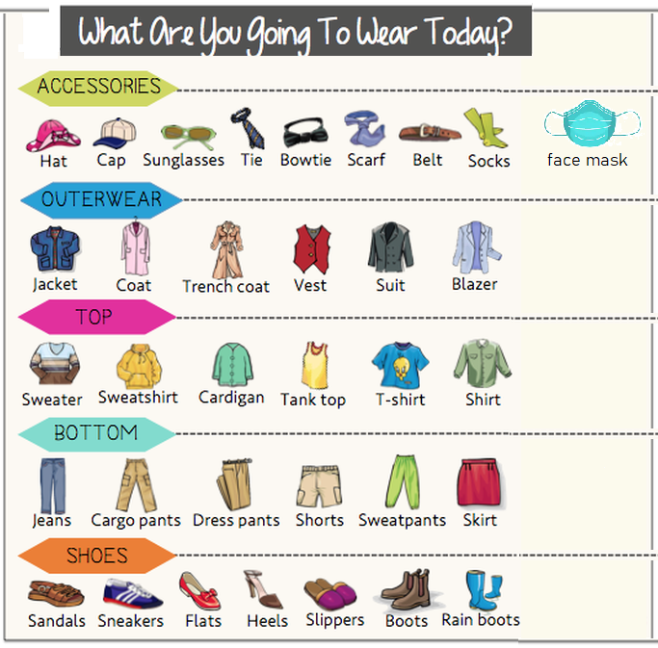

- Follow the link and play the game. https://www.gamestolearnenglish.com/clothes-game/

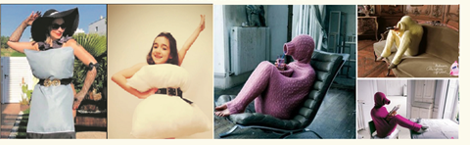
- What are you wearing today in quarantine?
QUARANTINE LOOKS

Example: Mica's wearing a pink jumper, grey leggings, black and pink trainers, black glasses and headphones. She´s listening to music. | 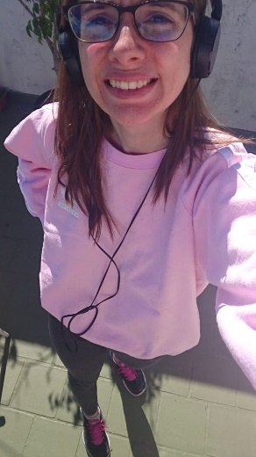
Example: Gaby ‘s wearing a grey sweatshirt, blue jeans, grey trainers, black glasses and a home-made face mask.  She’s going to the supermarket. | 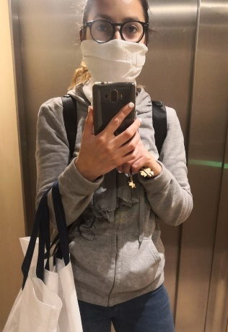
I’m wearing… | Your picture here  …
Press ctrl and click to listen to the audio file:
https://bit.ly/2RMuFCx

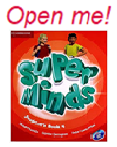
Now, open your books on page 10!

- LOOK! Ben and Lucy are in the …
- The symbol of this unit is a …

- Listen and say the words.
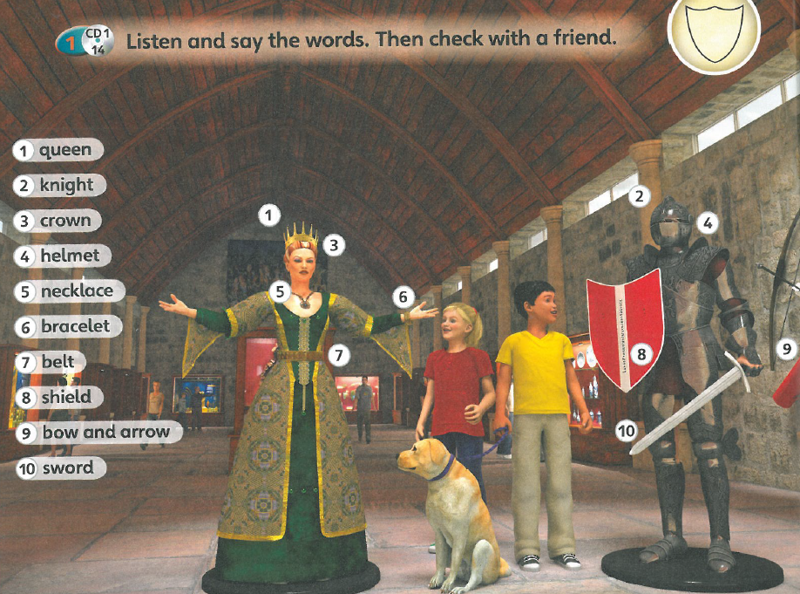

- Look at the picture in activity 4 again and put the words in the correct column.

belt - sword - bow and arrow - bracelet - shield - necklace - helmet - crown
What does a queen wear? | belt  …  …  …
What does a knight wear? | …  …  …  …

Press ctrl and click to listen to the audio file:
https://bit.ly/2XKYRlB
- Ben and Lucy are following the instructions on the map to find the treasure. The first symbol is a shield. They go to the museum to find it!

Listen and correct the sentences. (Exercise 2, page 10)

- There is a helmet on the map.
There is a shield on the map.
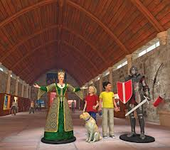
- Ben is talking about the helmet.
…

- Lucy would like the queen’s crown.
…

- They go to the dinosaur room.
…
- Follow the link and create your superhero.
(When you finish, press “guardar como/save as” on the right button to save your image.
https://learnenglishkids.britishcouncil.org/games/style-hero

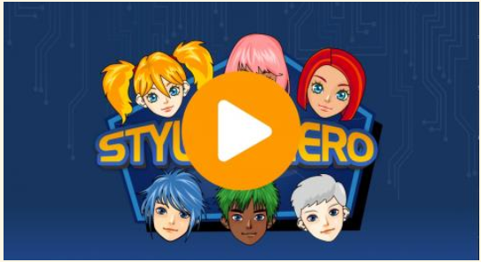

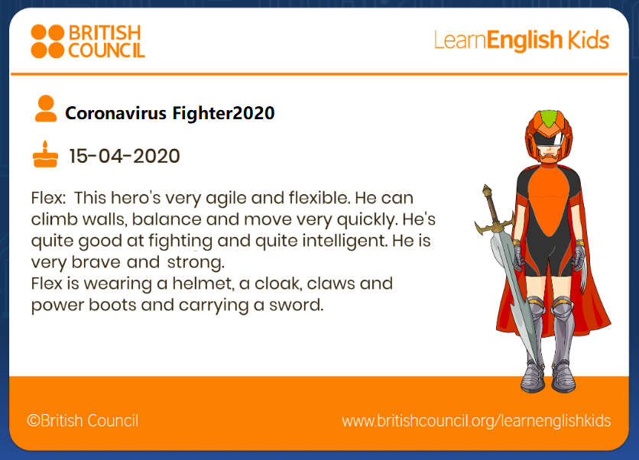
Share your superhero here!
…

What was your favourite activity today? Activity number …

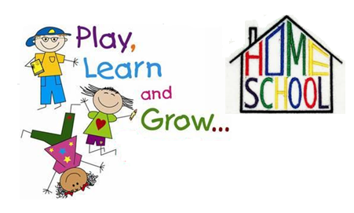
This is the end of your file. Check you have solved all the activities, save your work and send it to your teacher via email:
4th Girls and Boys: msgabygar@gmail.com

