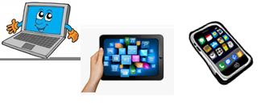
Name :…
Surname: …
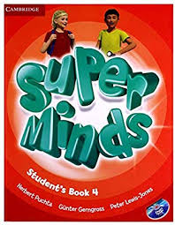
Home Schooling 12
- Today we keep on working on unit 1 of Superminds 4 (“In the Museum”)

- Let’s revise the vocabulary we learnt last class. Follow the link and complete the form. Choose the correct picture.
https://forms.gle/BuNHbyFS5sb545AV9

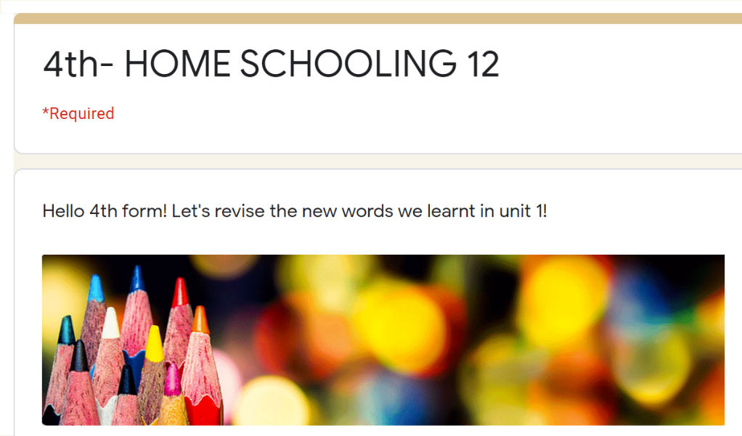

- Now, let’s play hangman! Follow the link: https://bit.ly/2VjoU1i
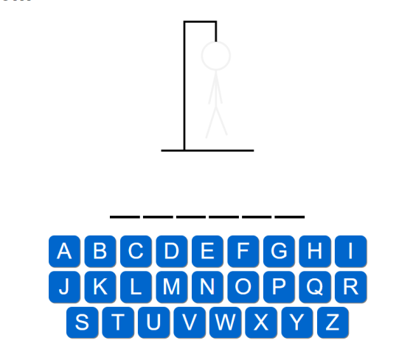

- Complete the words. Then, match.

 | sword | E
 | … | …
 | … | …
 | … | …
 | … | …
 | … | …
 | … | …
 | … | …
 | … | …
 | … | …
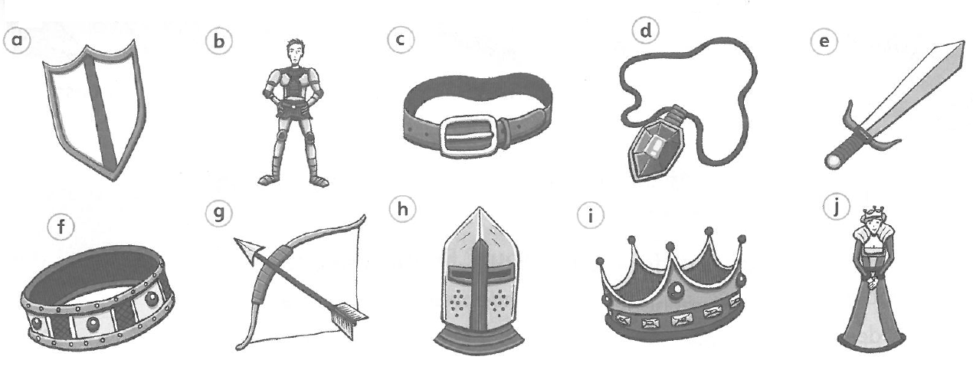

- Imagine we are in a MUSEUM! Do you know the rules?
shout - dance - speak quietly - touch objects - turn off my mobile - pay attention
…  …  … | shout  …  …
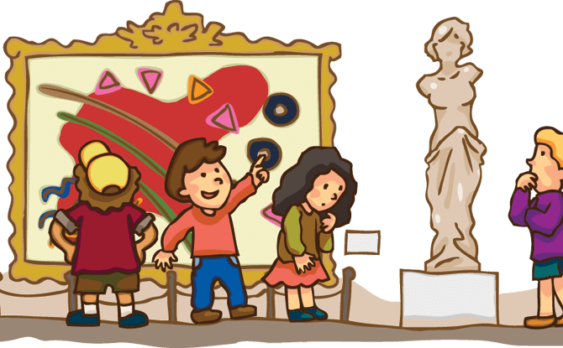

This is the end of your file. Check you have solved all the activities, save your work and send it to your teacher via email:
4th Boys: msmicaelaferrero@gmail.com
4th Girls: msgabygar@gmail.com

