Name: …
Surname: …
Home Schooling 19
Today we´ll continue working on unit 1 of Superminds.

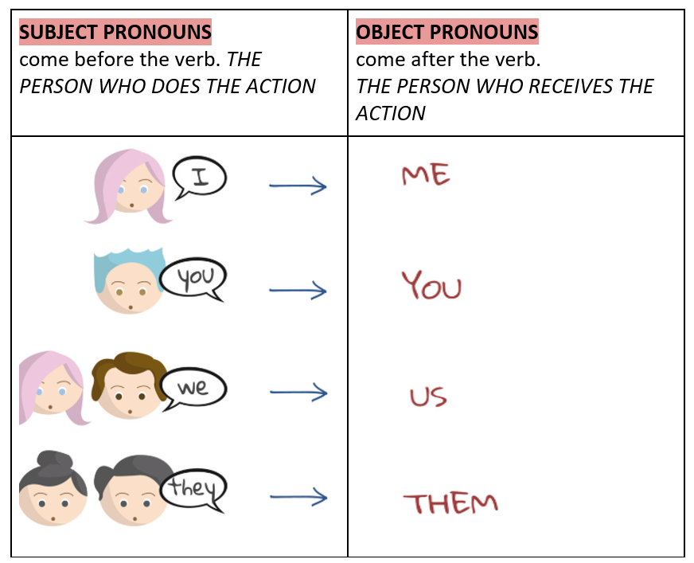

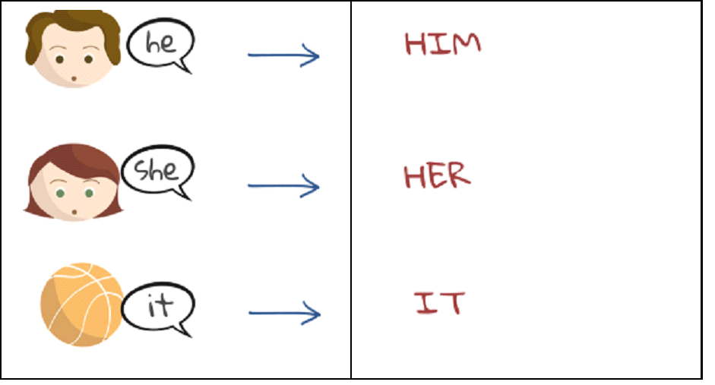

- Follow the link and play the game:
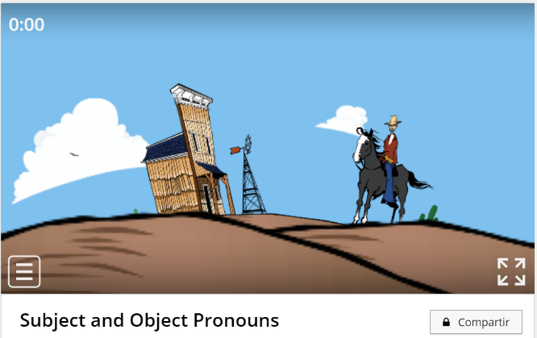
CLICK HERE: https://wordwall.net/play/2243/014/998

NOW GO ONLINE

CTR+CLICK AND WORK ONLINE
https://forms.gle/Agodh5JiuQnznQTW6
PLEASE PRESS “SUBMIT/SEND” AT THE END OF YOUR ONLINE WORK (POR FAVOR PRESIONAR “ENVIAR” AL FINAL DEL TRABAJO EN LINEA)
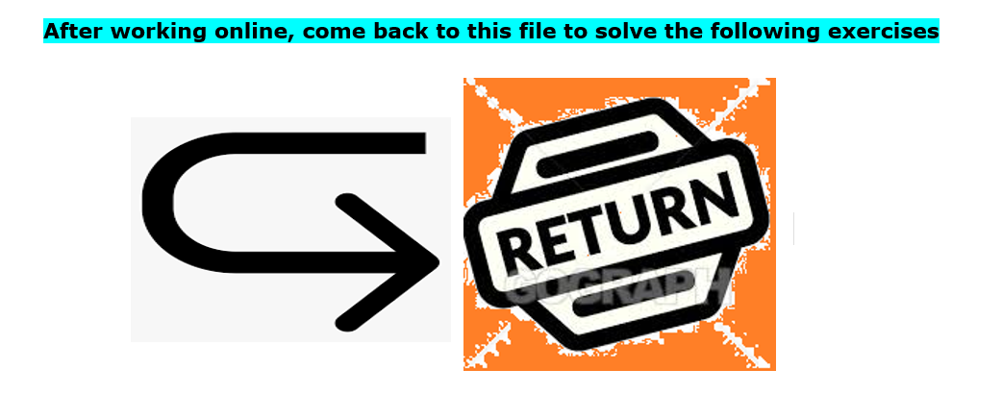
2- Correct the mistakes

- I really like Katie, but she never notices I.
…

- My brother lives in Mexico, I don’t see he very often.
...

C-Peter: How are your parents?
Tom: Fine. I saw they yesterday.
...

D-This dress looks a bit small. Do you think it will fit she?
...

3. Follow the link and sing!
CLICK HERE: https://bit.ly/2LtUsvS
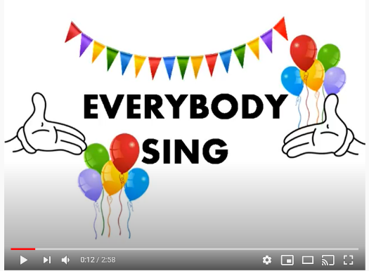

This is the end of your file. Check you have solved all the activities, save your work and send it to your teacher via email:
4th Girls and Boys: msgabygar@gmail.com

