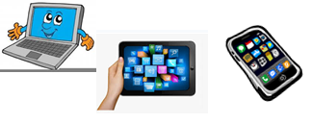
Name:…
Surname: …
Home Schooling 20
Today we´ll finish working on unit 1 of Superminds. We’ll read the story!

- Follow the link to work on page 119 of Superminds to revise Unit 1.
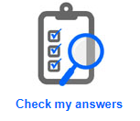
CLICK HERE: https://www.liveworksheets.com/sb513229bp
Press “Terminar” and then Check my answers.
STORY TIME

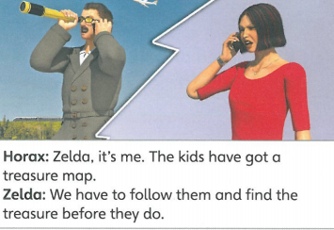
2- Look at the last scene from the previous chapter and think.
What happened in the previous chapter?
...

3- Look at the first scene of the new story.
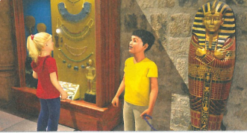 | Where are they?  ...
Describe the items in the background using your own words
…

NOW GO ONLINE

CTRL+CLICK AND WORK ONLINE
https://forms.gle/MFc6TZCmqijKoVTcA
PLEASE PRESS “SUBMIT/SEND” AT THE END OF YOUR ONLINE WORK (POR FAVOR PRESIONAR “ENVIAR” AL FINAL DEL TRABAJO EN LINEA)

This is the end of your file. Check you have solved all the activities, save your work and send it to your teacher via email:
4th Boys: msmicaelaferrero@gmail.com
4th Girls: msgabygar@gmail.com

