Name:…
Surname: …
Home Schooling 5
- Do you like parties? What did you do in your last birthday party? Write 3 sentences about it. You can use the verbs from the box or others.
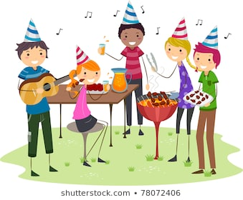
danced
ate
listened
played
sang
went
saw
watched

1) I ate chocolate cake.
2) …
3) …
4) …

- This is Emma. She had a party last week. What did she do at the party? Listen and write YES or NO.
https://drive.google.com/file/d/1D_0HOgajWaz7uaiQ7sNdaUbsteCzxxwe/view?usp=sharing

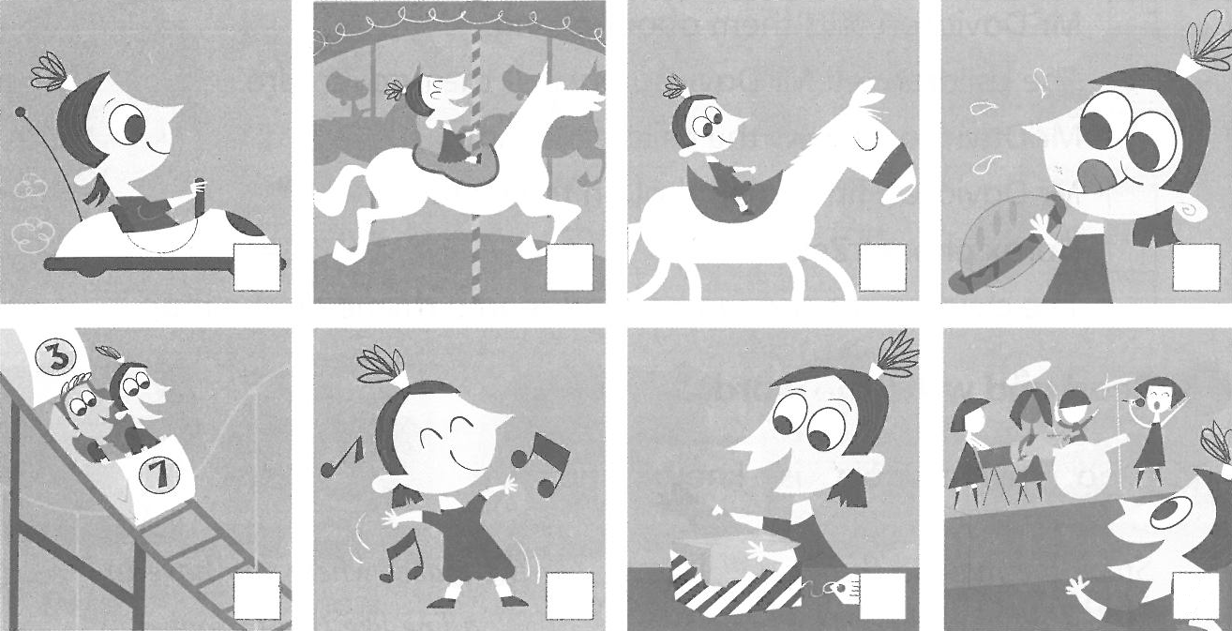
…
…
…
…
YES
…
…
…

- Do you remember the questions we studied last class?
Simple Past questions
We use simple past to ask what people did in the past.
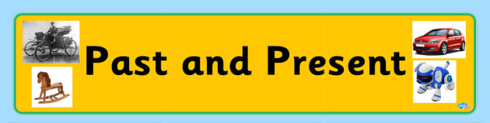
- We use WAS, WERE or DID to make questions.

- Were you at home yesterday? Yes, I was No, I wasn´t
- Was he/she in the kitchen? Yes, he/she was No, he/she wasn´t

- Did you/he/she/we/they watch TV? Yes, I did No, I didn´t

Now read and complete the questions to ask Emma about her party.

- What was the party like?
- … there a band?
- … you dance?
- … there a barbecue?
- … you have a lot of fun?
- … there dodgem cars?

4. Now answer the questions below about a party you had.
- What was the party like?
…
- Were there a lot of people?
…
- Was there a band?
…
- Did you dance?
…
- Did you have fun?
…
This is the end of your file. Check you have solved all the activities, save your work and send it to your teacher via email:
4th Girls and Boys: msgabygar@gmail.com

