Name:…
Surname: …
Home Schooling 6

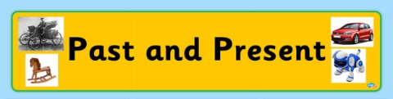
Let’s talk about THE PAST

- Study the chart with the PRESENT and PAST forms of the verbs.

TO WANT | WANTED | 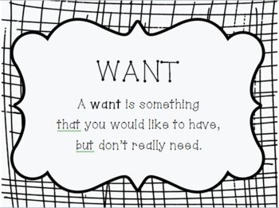
TO PHONE | PHONED
TO CHECK | CHECKED | 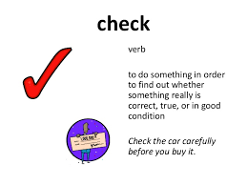
TO WAIT | WAITED | 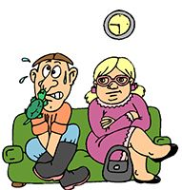
TO DECIDE | DECIDED
TO STOP | STOPPED
TO RAIN | RAINED | 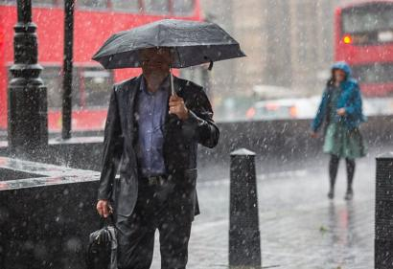

2) Play this memory game. Match the verbs in the present with the verbs in the past. https://www.educaplay.com/learning-resources/5312086-verbs.html
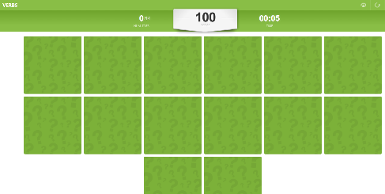

- Watch the video and complete the activity in the webpage. When you finish, click on “Terminado” and “comprobar mis respuestas” to check your answers. 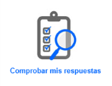

https://es.liveworksheets.com/worksheets/en/English_as_a_Second_Language_(ESL)/Past_simple/Past_Simple_Regular_Verbs_-_Video_xt37682kg
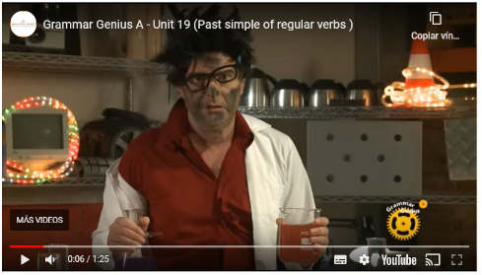

- Choose 3 verbs from exercise 1 and write examples of your own.

- Yesterday I wanted to eat “pastafrola”. I looked for a recipe on the Internet and made it. It was delicious!
- …
- …
- …

- Follow the link and choose the correct option. Miss Gaby will receive your answers. https://forms.gle/8ebdrZorSd5jLyCd7

- Write questions for the answers.

- What did you do last night?
Last night? I watched TV.

- …?
I watched a film.

- …?
Yes, it was a really good film.

- …?
No, I didn´t watch the match. I don’t like football.

- …?
I went to bed at 10 o´clock.
This is the end of your file. Check you have solved all the activities, save your work and send it to your teacher via email:
4th Girls and Boys: msgabygar@gmail.com

