Name:…
Surname: …
Home Schooling 7
Today we are going to work on REGULAR and IRREGULAR verbs in the past.
REGULAR VERBS: we add -ed to change them into the past.
Example: I play computer games every day. (Present)
I played with baby toys when I was 2 years old. (Past)

- Juanita is Miss Gaby’s dog. Let’s see what she did yesterday during quarantine!

Listen - Listened | Juanita listened to music. | 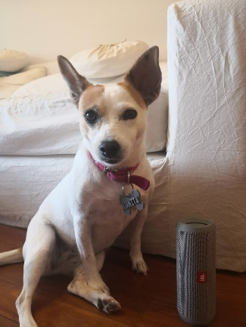
Dance - Danced | Juanita danced reggaeton. | 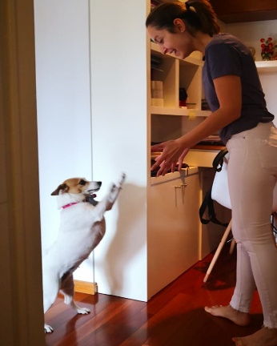
Play – Played | Juanita played with her toy. | 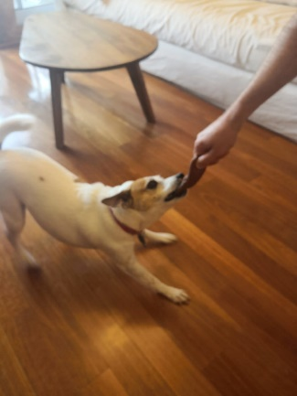
Study- Studied | Juanita studied English. | 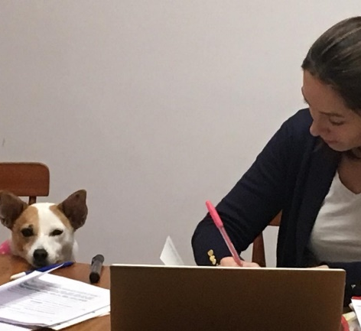
Watch - Watched | Juanita watched TV. | 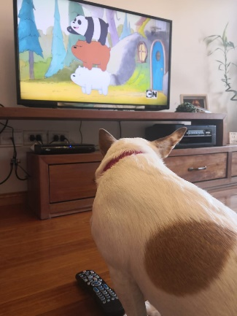

IRREGULAR VERBS: They are a bit crazy! We have to study and memorize them because they have special forms. They change completely.
Example: Sometimes I drink coke. (Present)
I drank milk when I was a baby. (Past)

- Let’s see how irregular verbs change. What did Juanita do yesterday?
Leave – left  Meet – Met  Go - Went | Juanita left home at 6pm. She met her friend, Garoto, and went for a walk. | 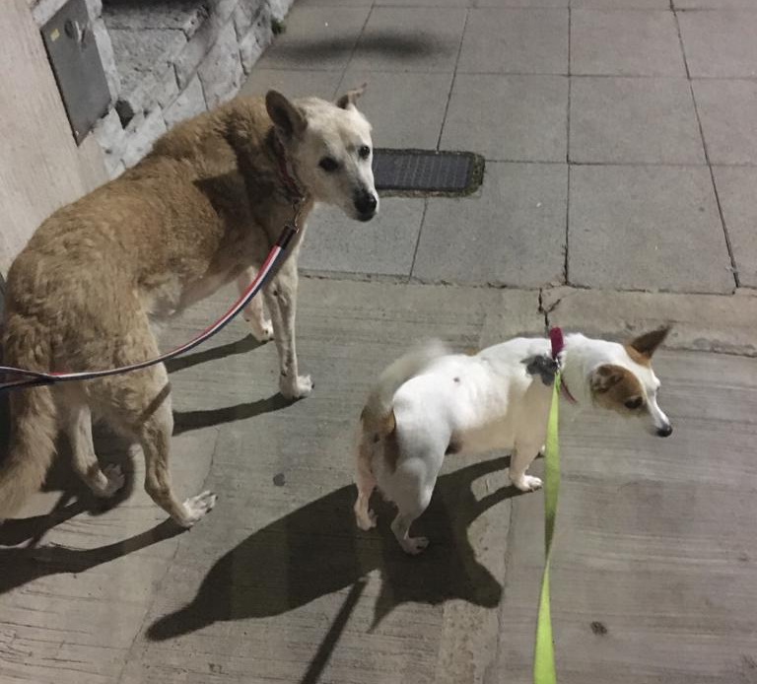
Sit – Sat  See - saw | Juanita sat on a chair on the balcony and saw the cars and motorbikes. | 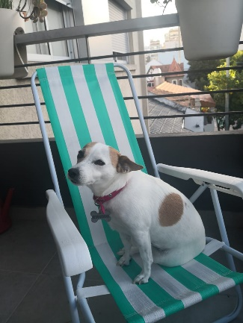
Take - Took | Juanita took a lot of selfies. | 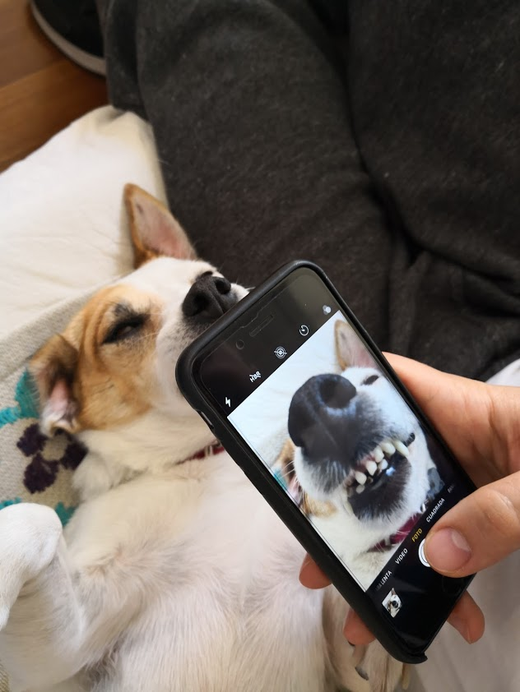
Have – had  Eat – Ate  Drink – Drank | Juanita had lunch: She ate barbecue and drank water. | 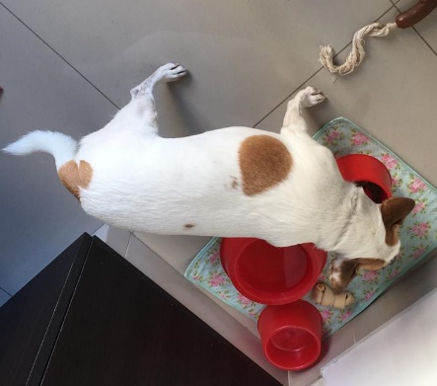
Do – Did  Read - Read | Juanita read Superminds and did her English homework. | 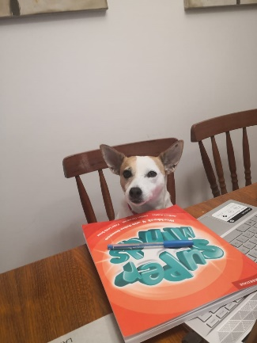
Be – was / were  Sleep - Slept | Juanita was tired. She slept on the sofa.

- Put the verbs in the correct column.
walk listen buy take dance play have study watch go see eat
REGULAR VERBS | IRREGULAR VERBS
Walk  …  …  …  …  … | Buy  …  …  …  …  …

- Match the verbs in exercise 1 with their past forms.
REGULAR VERBS
Present | Past
walk | walked
… | played
… | listened
… | studied
… | danced
… | watched
IRREGULAR VERBS
Present | Past
Buy | bought
… | went
… | ate
… | took
… | saw
… | had

- Complete the sentences using each verb in its past form.
go
eat
play
do
watch
leave
drink
have

- Nelly played volleyball with Jane in the patio.
- I … a film on Netflix with my family last night.
- We … lasagne and … apple juice for dinner yesterday.
- I … my math homework and then I … lunch.
- My mum … home at 9am and … to the supermarket.

- Watch the video and complete the activity on the webpage. When you finish, click on “Terminado” and “comprobar mis respuestas” to check your answers. 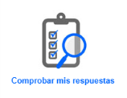
https://es.liveworksheets.com/worksheets/en/English_as_a_Second_Language_(ESL)/Past_simple/Past_Simple_Irregular_Verbs_-_Video_ga37680tv

- What did you do yesterday during quarantine?
Write 5 sentences about your day. Include pictures!

- … | Picture here
- … | Picture here
- … | Picture here
- … | Picture here
- … | Picture here

Did you enjoy it? …
This is the end of your file. Check you have solved all the activities, save your work and send it to your teacher via email:
4th Girls and Boys: msgabygar@gmail.com

