Name:…
Surname: …
Home Schooling 8

We use SIMPLE PAST to talk about what people did in the past.
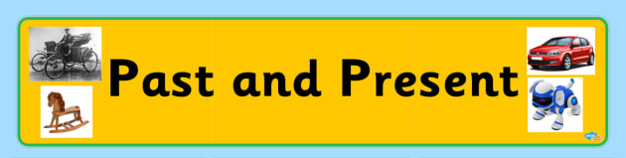

PAST PRESENT
Yesterday, I watched T.V. Today, I’m watching T.V.

There are two types of verbs we can use….
REGULAR VERBS | IRREGULAR VERBS
They are really nice verbs! They like to follow rules.  We add –ed to change them into the past.  Example:  PRESENT: When I finish doing my homework, I watch T.V.  PAST: I watched T.V. yesterday. | They are crazy!!!! They don’t like rules, so we have to memorize them!  Example:  PRESENT: I usually buy books, because I like reading.  PAST: Yesterday, I bought books.

TO MAKE QUESTIONS (?) OR NEGATIVE SENTENCES (-), WE NEED THE HELP OF OUR SPECIAL FRIEND:
DID!!!
When we use DID, we don’t need to change the verb or to add –ed. LOOK HERE!
DID YOU WATCH T.V. YESTERDAY?

YES, I DID!

X NO, I DIDN’T
Yesterday, I didn’t watch T.V. after finishing my homework.

SPELLING RULES!
Sometimes regular verbs need to change a little so as we can add the -ed.

Look here!
The normal form is to add to the verb –ed  PLAY = PLAYED  WATCH = WATCHED | 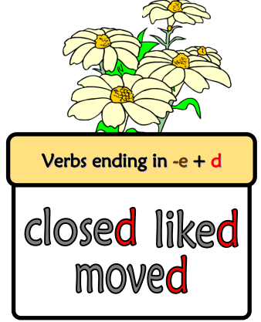  When the verb ends in –e, we only add –d  CLOSE = CLOSED  LIKE= LIKED  MOVE=MOVED
When the verb ends in a consonant + y, we change the y to I and we add –ed  STUDY: D IS A CONSONANT + Y = STUDIED  CARRY = CARRIED | When we have this combination in a verb: CONSONANT + VOWEL + CONSONANT, we double the consonant and we add –ed  STOP (T- CONSONANT + O- VOWEL + P-CONSONANT)  STOP = STOPPED  PLAN (L- CONSONANT + A-VOWEL + N-CONSONANT)  PLAN = PLANNED

REGULAR VERBS
- Watch the following video to understand more about regular verbs!
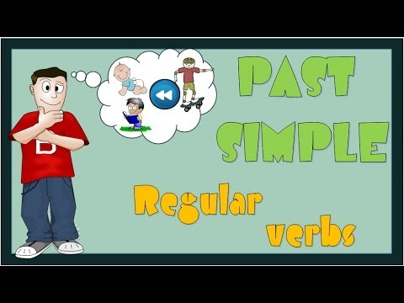

https://drive.google.com/file/d/1nbn2xjv2knRSay12EU5NFo6f4lxJH9s7/view?usp=sharing

- Complete the chart with the verbs. They can be in the simple present or in the simple past.
VERB IN THE PRESENT | VERB IN THE PAST
… | escaped
agree | …
try | …
… | enjoyed
… | happened
stop | …
fail | …

- Now complete the sentences using the verbs from above!
1. The cat … (escape) from the garden.
2. They … (agree) with me about the album.
3. He … (try) to start the car.
4. We … (enjoy) the funfair a lot.
5. Tell me, what … (happen)?
6. She … (stop) at a zebra crossing
7. Alfie … (fail) his driving test again.

- MULTIPLE CHOICE! Choose the correct option! Write A or B
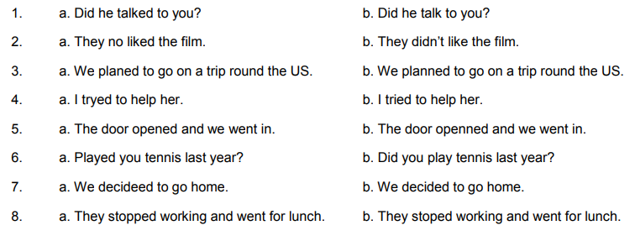

1 | …
2 | …
3 | …
4 | …
5 | …
6 | …
7 | …
8 | 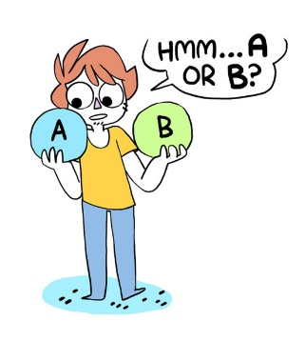  …

IRREGULAR VERBS
- Watch the following video to understand more about irregular verbs!
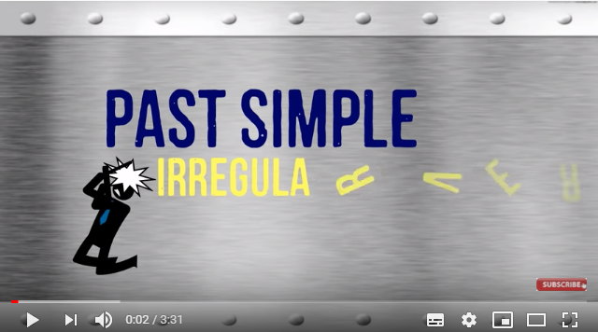
https://drive.google.com/file/d/1Yq6xxRGWGM4cyk3w2gK1-XVX7mjk53cV/view?usp=sharing

- Follow the link and find the simple past irregular verbs in the wordsearch. https://es.liveworksheets.com/worksheets/en/English_as_a_Second_Language_(ESL)/Irregular_verbs/Irregular_verbs_wordsearch_xl11312jg
When you finish, click on “Terminado” and “comprobar mis respuestas” to check your answers. 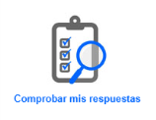
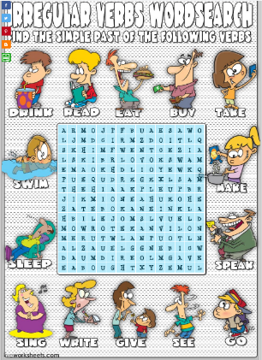

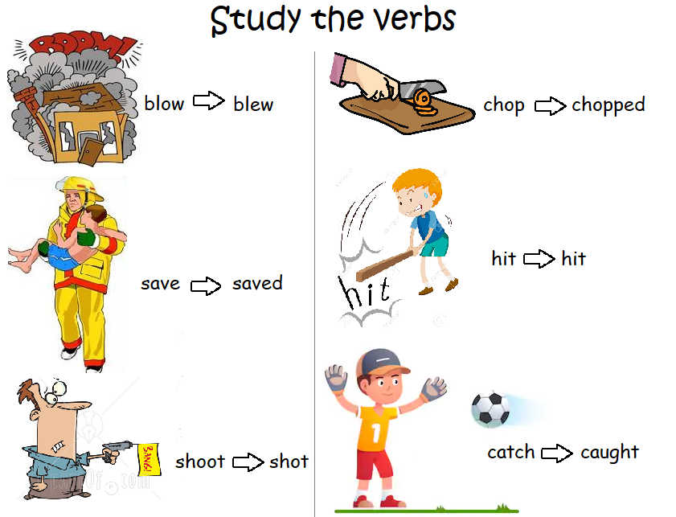
- First

Then watch the “Tom and Jerry” video and complete the sentences using the past simple.
https://en.islcollective.com/video-lessons/past-simple-jerry-and-goldfish

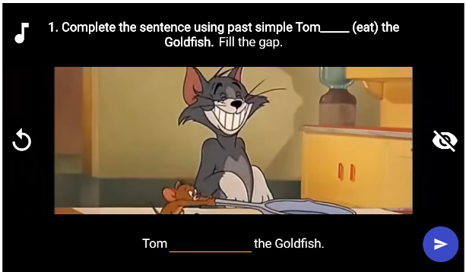

- Make the sentences negative.

- Tom ate the Goldfish.
Tom didn’t eat a cake.

2) Jerry and the Goldfish ran away from Tom.
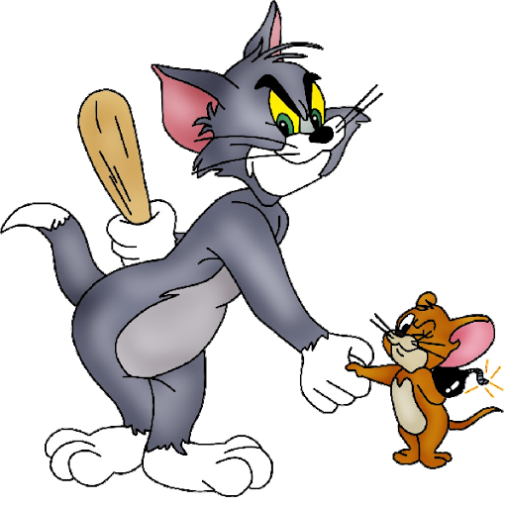
Jerry and the Goldfish … away from Mammy.

3) Jerry hit Tom.
Jerry … the goldfish.

4) Tom shot the Goldfish.
Tom … the Goldfish.

5) Jerry saved the Goldfish.
Mammy …the Goldfish.

6) Tom caught the Goldfish.
Tom … Jerry.

7) Tom chopped the potato.
Tom …the Goldfish or the carrot.

8) Jerry put Tom's tail under his paw.
Jerry… the Goldfish under his paw.

9) The pot blew up.
Jerry and the Goldfish … up.

- Now, choose two verbs from activity 1 and two from activity 4 and write four sentences.
Example: I tried to play the guitar, yesterday.
1. …
2. …
3. …
4. …

This is the end of your file. Check you have solved all the activities, save your work and send it to your teacher via email:
4th Girls and Boys: msgabygar@gmail.com

