***Name:… Surname: …***

***Home Schooling 3*** 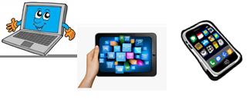

1. **Play the game and revise PRESENT SIMPLE.**

<https://view.genial.ly/5e6fed32362cb314dc4fc427/game-present-simple-revision?fbclid=IwAR3c4Ds3kC7BuyOjjZFfOWT4-Ux1ePHMq0rIujmnIaiXPKtYtHFOqN0WZQM>Resultado de imagen de click clipart

[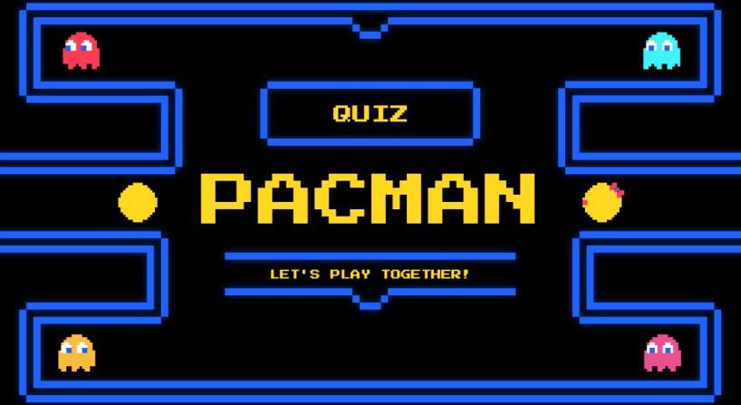](https://view.genial.ly/5e6fed32362cb314dc4fc427/game-present-simple-revision?fbclid=IwAR3c4Ds3kC7BuyOjjZFfOWT4-Ux1ePHMq0rIujmnIaiXPKtYtHFOqN0WZQM)

1. **Study the chart.**

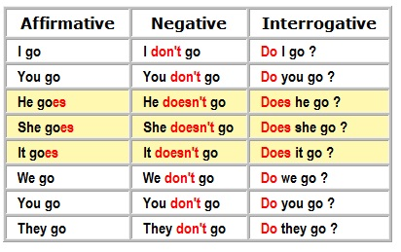

**3) Solve the activities:**

<https://agendaweb.org/verbs/present-simple/index.html> Resultado de imagen de click clipart

<https://agendaweb.org/exercises/verbs/do-does-exercises/negative-1.htm> Resultado de imagen de click clipart

**4) Make questions and match them to the pictures.**

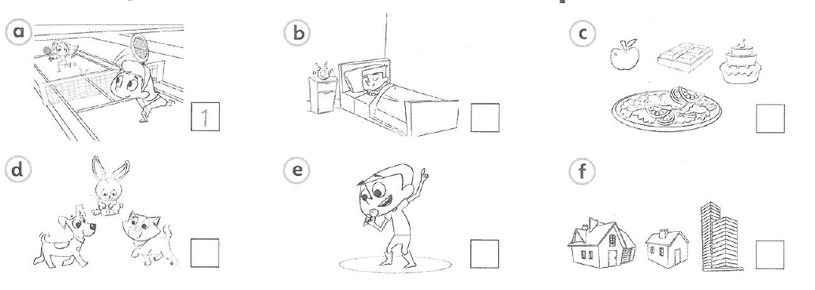

…

…

…

…

…

1

1. you / Do / playing / like / tennis ? Do you like playing tennis?
2. you / got / any / pets / Have ? …
3. Where / you / do / live ? …
4. your / What’s / food / favourite? …
5. singing / like / Do / you ? …
6. time / get / do / What / you / up / Saturdays / on? …

**4) Write your own answers to the questions.**

1. …

2. …

3. …

4. …

5. …

6. …

**5) Watch the story on Super Minds 4 (page 8 and 9) at:** <https://www.youtube.com/watch?v=8VXSvF5_GLU> Resultado de imagen de click clipart

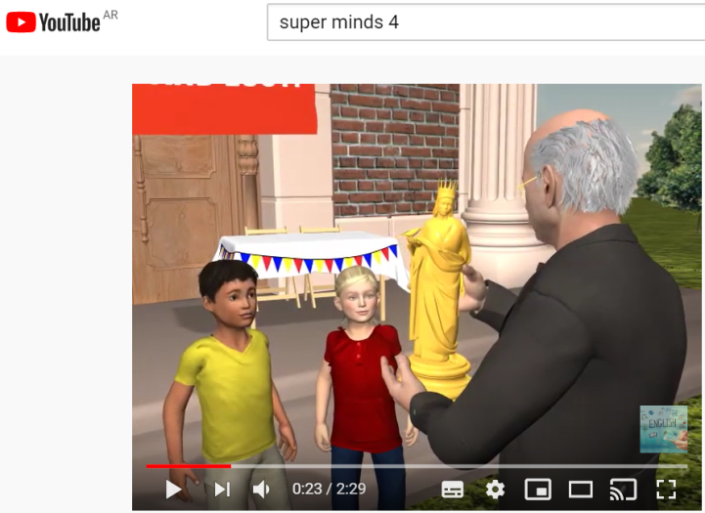

**6) Now, answer the questions.**

1. What does Mr Davidson find on the statue? *A symbol*

2. Where does he go? …

3. What does he get? …

4. What do Ben and Lucy have to do to find the treasure? …

5. Who is watching them? …

6. What are Horax and Zelda going to do? …



Did you enjoy it? …



This is the end of your file. Check you have solved all the activities, save your work and send it to your teacher via email:

4th Girls and Boys: [msgabygar@gmail.com](mailto:msgabygar@gmail.com)