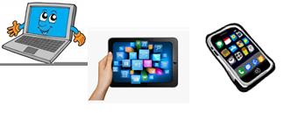***Name:… Surname: …***

***Home Schooling 13***

* ***Today we keep on working on unit 1 of Superminds (“In the Museum”)***
* Do know any museums in Buenos Aires? Which?

…

* When did you go?

…

* Who did you go with?

…

* Did you like it?

…

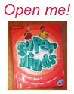

* **Now, open your books on page 11.**

1. **Let’s imagine we go to a museum on a school trip (after quarantine, of course!) Look at the rules, read and number the sentences.**



1. I must buy a ticket. 5
2. I must put my dog on a lead. …
3. I must leave my coat in the cloakroom. …
4. I must speak quietly. …
5. I mustn´t shout. …
6. I mustn´t run. …
7. I mustn´t touch anything. …
8. I mustn´t take photos. …

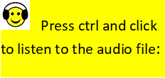

1. **Listen and say.** [**https://bit.ly/2Y7e1BQ**](https://bit.ly/2Y7e1BQ)

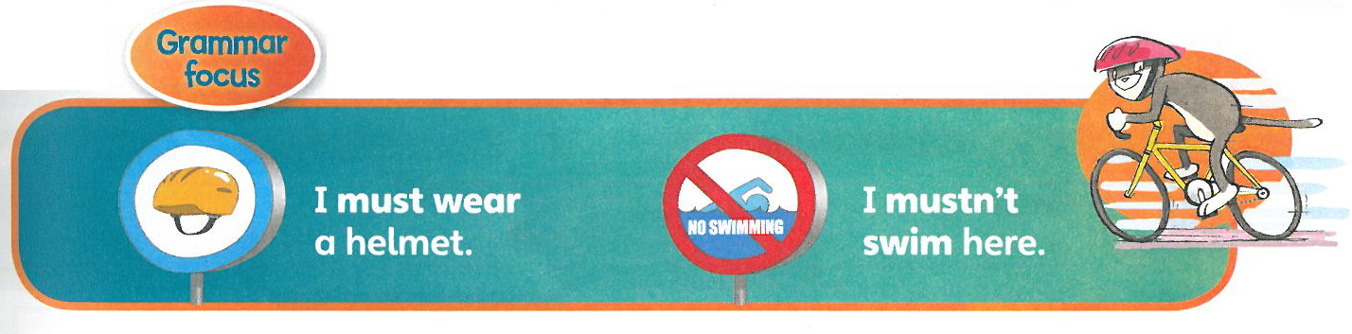

1. **Watch the video. Then, complete with MUST/ MUSTN’T.** <https://youtu.be/ZFC3wYnRm3g>Resultado de imagen de click clipart

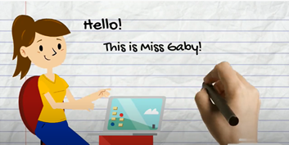

**Rules** are necessary everywhere: at school, home, sport clubs, museums, parks, hospitals, etc.



* We use **…** to talk about OBLIGATION.
* We use **…** to talk about PROHIBITION.

1. **Write the sentences next to the pictures.**



|  |  |
| --- | --- |
|  | *I mustn´t run in the living room.* |
|  | … |
|  | … |
|  | … |
|  | … |
|  | … |

1. **Read and write MUST or MUSTN´T and a word from the box.**

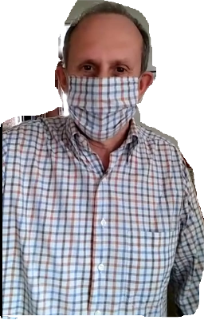

shout keep use ~~wear~~ drink buy

1. I must wear a facemask when I leave home.
2. I … … in the house when my baby brother is sleeping.
3. I … … too much coke. It isn´t good for my health.
4. I … … the dog on his lead. I don´t want him to escape.
5. I … … a school uniform on zoom classes.
6. I … … my camera here. The sign says “No photos”.

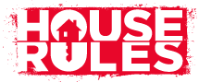

1. **What must or mustn´t you do at home?**

**Write 2 sentences with *must* and 2 with *mustn´t*.**

1. …
2. …
3. …
4. …



This is the end of your file. Check you have solved all the activities, save your work and send it to your teacher via email:

4th Girls and Boys: [msgabygar@gmail.com](mailto:msgabygar@gmail.com)